MBA Program

BUS-610 – Organizational Communication
Syllabus Version 01.2023
COURSE INFORMATION
BUS-610 – Sections 10 and 30/Organizational Communication, Spring 2024
Reinhardt University
Course Start Date: January 08, 2024
Course End Date: February 25, 2024

Faculty Contact Information
- Instructor: Dr. Joyce Boyd
- Email: Joyce.boyd@reinhardt.edu
- Office Location: Virtual
- Phone Number: 828-559-2502
- Class Location: Online via Canvas
- Office Hours: Monday-Thursday 12:00 PM EST - 1:00 PM EST
- Please don’t hesitate to email me with updates, questions, or concerns. I will typically respond within 24 hours, and usually much sooner. I will notify you if any contingencies may delay a response.
CATALOG COURSE DESCRIPTION
This course is an examination of modern concepts of effective business communications. Discussions focus on the theoretical bases of communication, the communication process, communication skills, case analysis, and development and implementation of business communication strategies.
COURSE LEARNING OBJECTIVES
By the end of this course, students will...
- Analyze Communicative-Leadership theory against a backdrop of organizational communication theoretical underpinnings.
- Develop a selected tool of strategic communication.
- Apply persuasive techniques to messaging designed to persuade.
- Construct an audience analysis.
- Develop a story aligned to a specific organizational goal.
- Interpret organizational-story frameworks and their application to communication.
- Describe current topics in organizational communications, social media, and the effect of remote work on organizational culture.

REINHARDT CREDIT-HOUR STATEMENT: 3-CREDIT-HOUR CLASS
Over 7 weeks, students will spend a variable number of minutes per week in online lectures, class discussions, and in preparation of class projects and research papers. Out-of-class work includes homework and is a variable number of minutes per week (6,750 minutes for the semester).
REQUIRED TEXTS
- Cialdini, R., Influence, New and Expanded: The Psychology of Persuasion: ISBN-13: 978-0063138803
- Booher, D., Communicate Like a Leader: ISBN-13: 978-1626569003
- Hutchens. Story Dash: ISBN-13: ISBN 9781953295446
CANVAS
You must have regular access to a computer and an Internet connection to participate in this course. All coursework is conducted online, and no in-person meetings will be held. Canvas is the learning management system at Reinhardt. If you need more information about how Canvas works, you can review the training manual online.
Here are directions for logging into the Canvas:
Open a browser and go to: https://reinhardtuniversity.instructure.com/login/ldap
You can find our class at https://reinhardtuniversity.instructure.com/courses/10001/modules (but may need to log in through above)

ASSIGNMENTS AT A GLANCE
 | Week | Topic | Discussion | Written Assignment | Due*
 | Week 1 | Communication + Leadership | Introduction Forum | Assess Self as Communicative Leader | Jan 14
 | Week 2 | Communication Strategy in the Organization | Strategic Internal Communication Initiative | Informational Interview w/Communicator | Jan 21
 | Week 3 | Persuasion | Persuasion vs. Manipulation | Persuasive Email or Phone Script | Jan 28
 | Week 4 | Audience | Audience Analysis for Difficult Communication | Audience Analysis | Feb 04
 | Week 5 | Applied Storytelling 1 | Story Mining | Telling the Story + Peer Review | Feb 11
 | Week 6 | Applied Storytelling 2 | SAR-PAR-CAR Story | Revised Story | Feb 18
 | Week 7 | Communicating in the Age of Zoom | Social-Media Post about Communication Intervention for Org  Culture Weakened by Remote-Work Climate | Final Assignment | Feb 25
*while Sunday at 11:59 pm is the deadline for discussions to be completed with replies to 2 peers, initial posts are due on Wed.
ATTENDANCE
You are required to participate weekly in the discussions. Attendance will be measured based on your online activity throughout the course.

CLASS PARTICIPATION AND PERFORMANCE
Reading Policy:
Reading and understanding of subject matter are major components for this course. Make sure to read all assigned chapters.
ASSIGNMENTS
Threaded Discussions:
In a traditional classroom, each student would be expected to attend class regularly and interact with the professor and with the other students. The online classroom is no different. The discussion forum allows you to reflect on each week’s material individually, but more importantly, it also allows you to discuss the material with one another and learn as a community. Each week’s discussion forum will have a topic that will either require you to submit a small project or critically engage with an issue.
Guidelines for Threaded Discussion Forum:
- Your initial response to the topic will be posted no later than Wednesday at 11:59 PM.
- You will provide two (2) substantive responses to classmates’ posts by Sunday at 11:59 PM.
- All responses should be thorough and expound on the concepts of the topic. Do your research and included references in APA format. Remember, this is a learning environment so ensure that you are adding knowledge and value to the topic.
Written Assignments:
Each weekly “written” assignment will be a model of application of the concepts. Your submission should be well-written/well-produced and clear.

Course Project:
An assigned course final project requires you to apply the knowledge you’ve gained throughout the course. The project is related to the concepts covered in the class and based on real-work experience in your organization.
LATE SUBMISSIONS
No late work accepted unless arrangements have been made BEFORE the due date and/or in exceptional circumstances on a case-by-case basis. Discussion posts will never be accepted late.
Technical issues/lack of Internet connectivity are not considered valid grounds for late submission of assignments or discussion posts. This is an online class; don’t travel to a destination where a reliable Internet connection is uncertain.
INSTRUCTIONAL METHODS
- Threaded discussions in Canvas
- Required textbook reading
- Reading and viewing of lectures and instructor content (articles and videos) on Canvas
- Use of Canvas for collecting assignments and distributing class materials.

Week/ Module | Topic(s) | Learning Objectives.  By the end of this week, students will …
1 | Communication + Leadership:  - Theoretical Underpinnings  - The Communicative Leader  - Leadership/Executive Presence | - Identify a workplace communication issue  - Assess characteristics of a communicative leader  - Apply organizational-communication theory to personal communicative-leadership style  - Analyze the importance of communication to leadership  - Appraise personal leadership/executive presence
2 | Communication Strategy in the Organization  - Internal and External Communication  - Tools of Strategic Communication | - Develop a strategic internal-communication initiative.  - Reflect on communication with a professional communicator  - Distinguish among 3 types of strategic communication tools
3 | Persuasion  - Persuasive Techniques  - Overcoming Objections | - Apply a persuasive technique to a specific situation.  - Demonstrate persuasive techniques in written communication.  - Strategize handling objections in a persuasive communication.  - Differentiate between persuasion and manipulation.
4 | Audience  - Audience Analysis: Spoken Communication  - Audience Analysis: Written Communication | - Devise an approach to audience analysis for a difficult communication.  - Design an Audience Analysis form for a specific type of organizational communication.  - Organize a strategic-communication plan
5 | Applied Storytelling 1  - Effectiveness of Applied Storytelling in Organizations  - Message Development with Stories  - The Story Dash Process | - Identify stories with workplace applications.  - Apply 1 specific story framework to developing a story.  - Select a communication mode or message to which to apply the developed story.  - Practice telling the developed story on video.
6 | Applied Storytelling 2  - Story Frameworks  - Storytelling in the Job Search | - Construct a story in response to a behavioral job-interview question using a specific story framework.  - Integrate feedback to improve a story.  - Conduct peer review on a story.  - Revise a story told on video.
7 | Communicating in the Age of Zoom  - Presentation Skills + Tools on Video/Videoconferencing  - Social Media  - Communicating Organizational Culture in Remote-Work Climate | - Devise a communications approach to enhancing company culture.  - Design a social-media post about the communications approach.  - Apply presentation skills to a recorded videoconference.  - Demonstrate visual-communication skills through a set of presentation slides.  - Demonstrate competency in using a videoconference platform.  - Produce a strategic-communication plan.

WEEKLY TOPICS AND LEARNING OBJECTIVES

GRADING AND EVALUATION CRITERIA AND POLICIES
  - 600 points are available in this class.
  - Students will be assessed, in part, via one discussion weekly. Discussions (initial post + at least 2 replies to peers) are worth 20 points each.

  - In addition, each week requires a Written* Assignment. See specific assignments for word-count requirements and specifications for APA-compliance and how you are to use sources. DO NOT include large (40 or more words) blocks of quoted text in Written Assignments. See also >> READ THIS!
IMPORTANT: Limitations on Use of Direct Quotes in this Class.

*While labeled Written Assignments, three assignments, Module 5/Week 5 Assignment: Telling the Story, Module 6/Week 6 Assignment: Revised Story, and Module 7/Week 7 Assignment: Final Project. Written assignments are valued at 50 points.

  - Final Project is worth 160 points;

  - I place strong emphasis on writing and suggest you review Dr. Hansen's Handy Guide to Avoiding Writing Deductions, especially the Section "Automatic Deductions." Note that I will be lenient with the first assignment, and usually make deductions only when deductible errors are repeated and/or excessive. It's important to review your feedback on assignments each week and apply suggestions to future assignments.
  - See Rubrics at the end of this syllabus for all Discussions and Assignments.
  - This class assumes the student is working in a business/organizational environment; “organizational” may include sports teams or other organizations.
  - All assignments will be graded based upon the appropriateness of their presentation as well as on their content.
  - Grade corrections or appeals should be made within two-weeks of receiving your final grade.
  - If you would like to discuss your grades, you can email me.
  - If you feel that you have received an “unfair” grade for an assignment, you can opt to have the College Dean or any other faculty member he/she might assign to the project to grade the assignment, and you will receive the grade that they feel is earned for the assignment. However, if this grade is lower than the previously assigned grade by the instructor you will receive the final grade offered by the College Dean, so make sure you feel you have grounds for appeal. Please speak directly with the instructor concerning your grades.
  - Academic Honesty: Please see the section of the general catalog that describes the college policy on academic honesty. The policy provides descriptions of what violates the policy and of what penalties may be imposed for violations. Failing grades will be assigned for any work that does not meet the standards of academic honesty. Any violation of academic honesty can result in a failing grade in a course. If I detect or observe sharing of work, you will receive an F. Special note on using Artificial Intelligence (AI) tools, such as ChatGPT: Using AI to write your assignment constitutes plagiarism. I can easily spot AI writing and will check your sources; if your sources don’t back up what you’ve written, we will have a conversation about your assignment’s originality.

Grading criteria
Points: 600
Assignment | Points
Written Assignments | 6 * 50 = 300
Discussions | 7 * 20 = 140
Final project | 1* 160 = 160
total | 600

GRADUATE GRADING SCALE
Percentage of Points Earned | Corresponding Letter Grade
90 to 100 % | A
80 to 89% | B
70 to 79% | C
0 to 69% | F
NETIQUETTE
You are expected to discuss and collaborate on the discussion topic. Any abuse of the format, including degrading, bullying, sexual harassment, and/or any inappropriate comments will not be tolerated.
Disagreeing with another student is acceptable. However, support your argument and do it in a civil manner.
Netiquette is a set of rules for how to communicate effectively and politely online.

Effective written communications are an important part of online learning. In an online environment, misunderstandings can easily occur when basic rules of Netiquette (online etiquette) are not followed, such as using texting abbreviations or USING ALL CAPITAL LETTERS IN WRITTEN COMMUNICATIONS. Therefore, please use the following guidelines when communicating in this course:
- Using ALL capital letters in online communication indicates you are yelling. Limited use of capitalized words is acceptable when emphasis is needed. Underscoring and italics can also be used for emphasis.
- Use a descriptive subject line in emails and forum postings.
- Include your name in all emails; we can’t always tell who you are based on your email address.
- No derogatory comments, ranting or vulgar language is acceptable in any form of communication in the course. Respect for others and their views is expected.
- Please keep in mind that something considered offensive may be unintentional. If you are concerned about something that appears to be unacceptable, please inform the instructor via email.

ADDITIONAL SUPPORT FOR THE COURSE
ASO Students: Please notify me on the first day of class that you are an ASO student and if you need accommodations so we can prepare for the assistance in advance. Students with disabilities needing accommodations must contact Academic Support Office prior to contacting me during office hours.
Office 365: Through your technology fee at Reinhardt, you receive Office 365, which gives you access to Office 2013 for up to 5 devices. You can also download Office 2013 on a computer for just the time you are working on that machine (Office on Demand). Therefore, you should have no excuses to not do your assignments outside of class. Office 365 will be available to you as long as you are a Reinhardt student throughout the program. Through Office 365, you can view your Reinhardt email, save documents to OneDrive (cloud-based server), so you can access your files anywhere, and manage your calendar.
Remember, the online course is subject to WIFI connectivity, and the No. 1 rule of management is to manage you first. Therefore, establish contingencies for outages, work schedules, unplanned emergencies. Expect the best but prepare for the worst.

RUBRICS
Grading rubrics for all discussions and assignments in this class appear on the pages following this one. Rubrics show you exactly how your assignments will be graded and how deductions are made. They tell you exactly what you need to do to succeed with each assignment and discussion.

Weekly Discussions

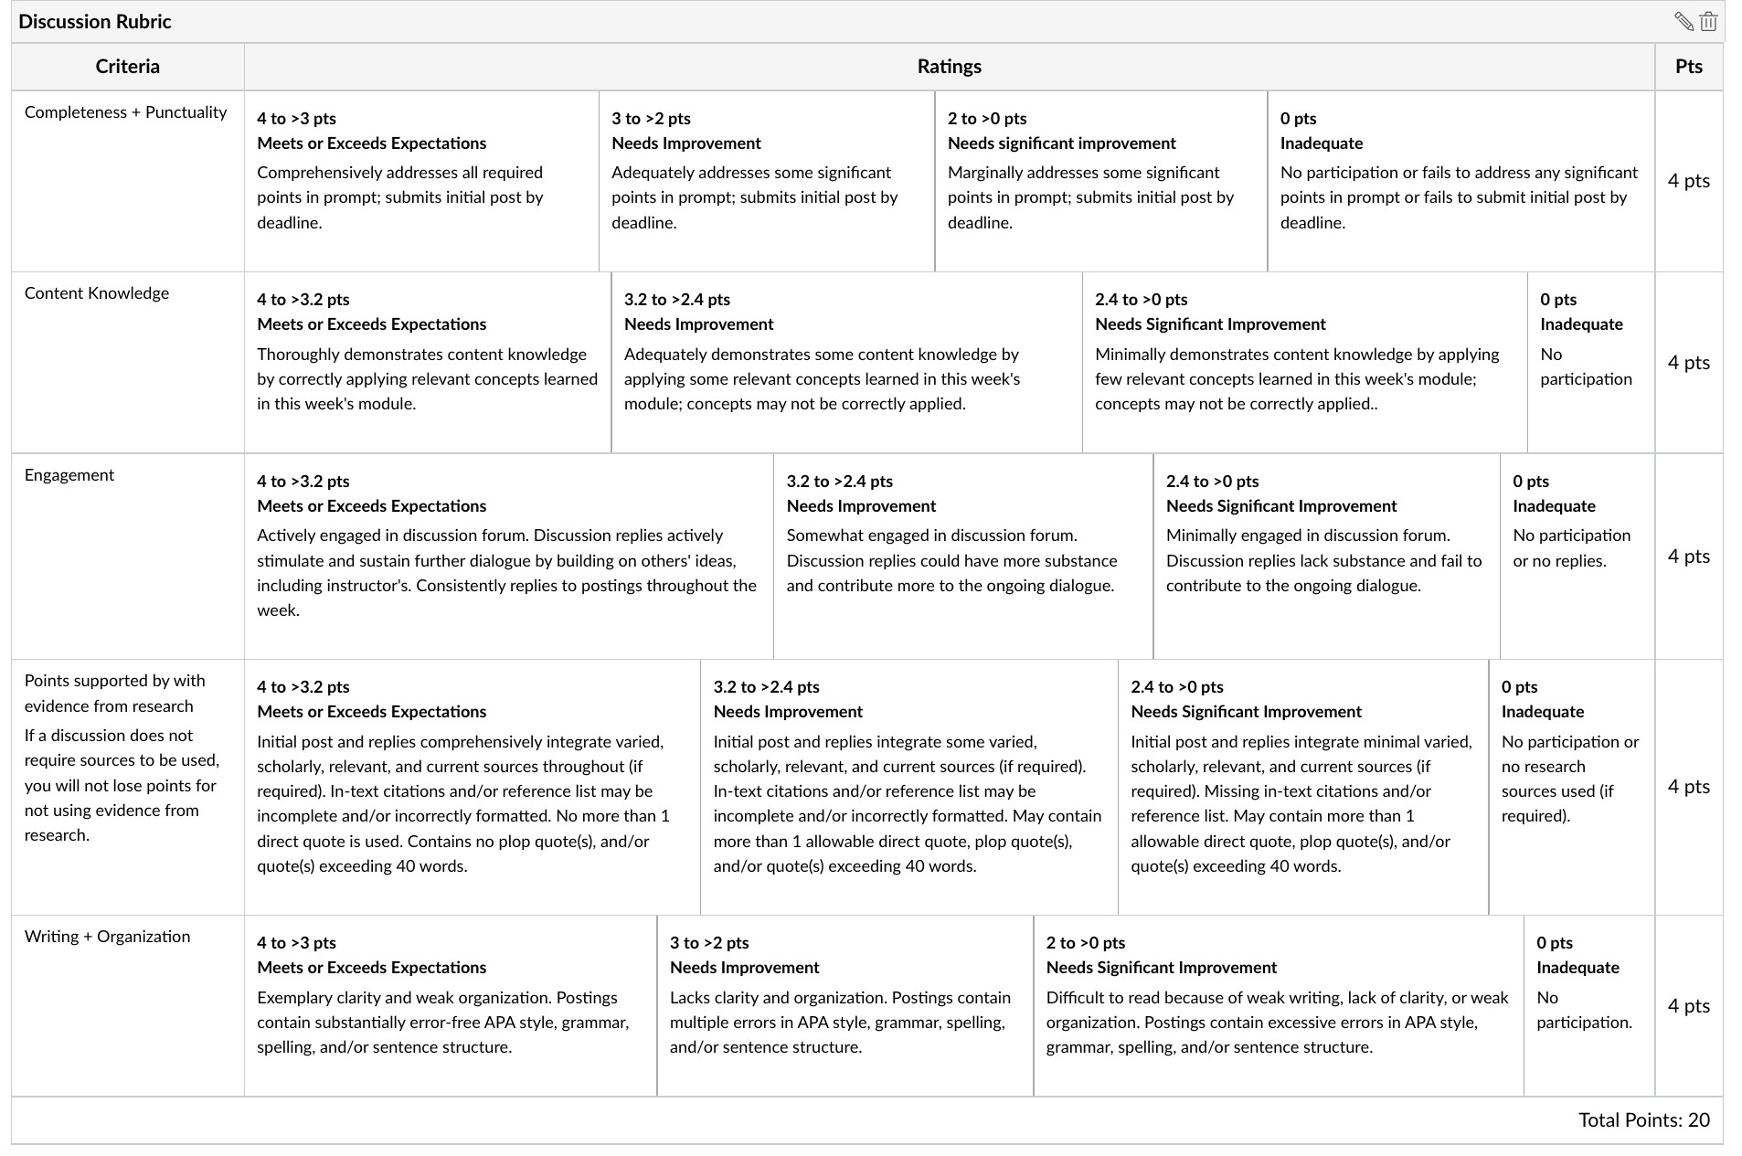
Note: For all Discussion Rubrics under Writing, the Meets or Exceeds category should omit the work “weak” and say: “Exemplary clarity and organization…”

For Written Assignments

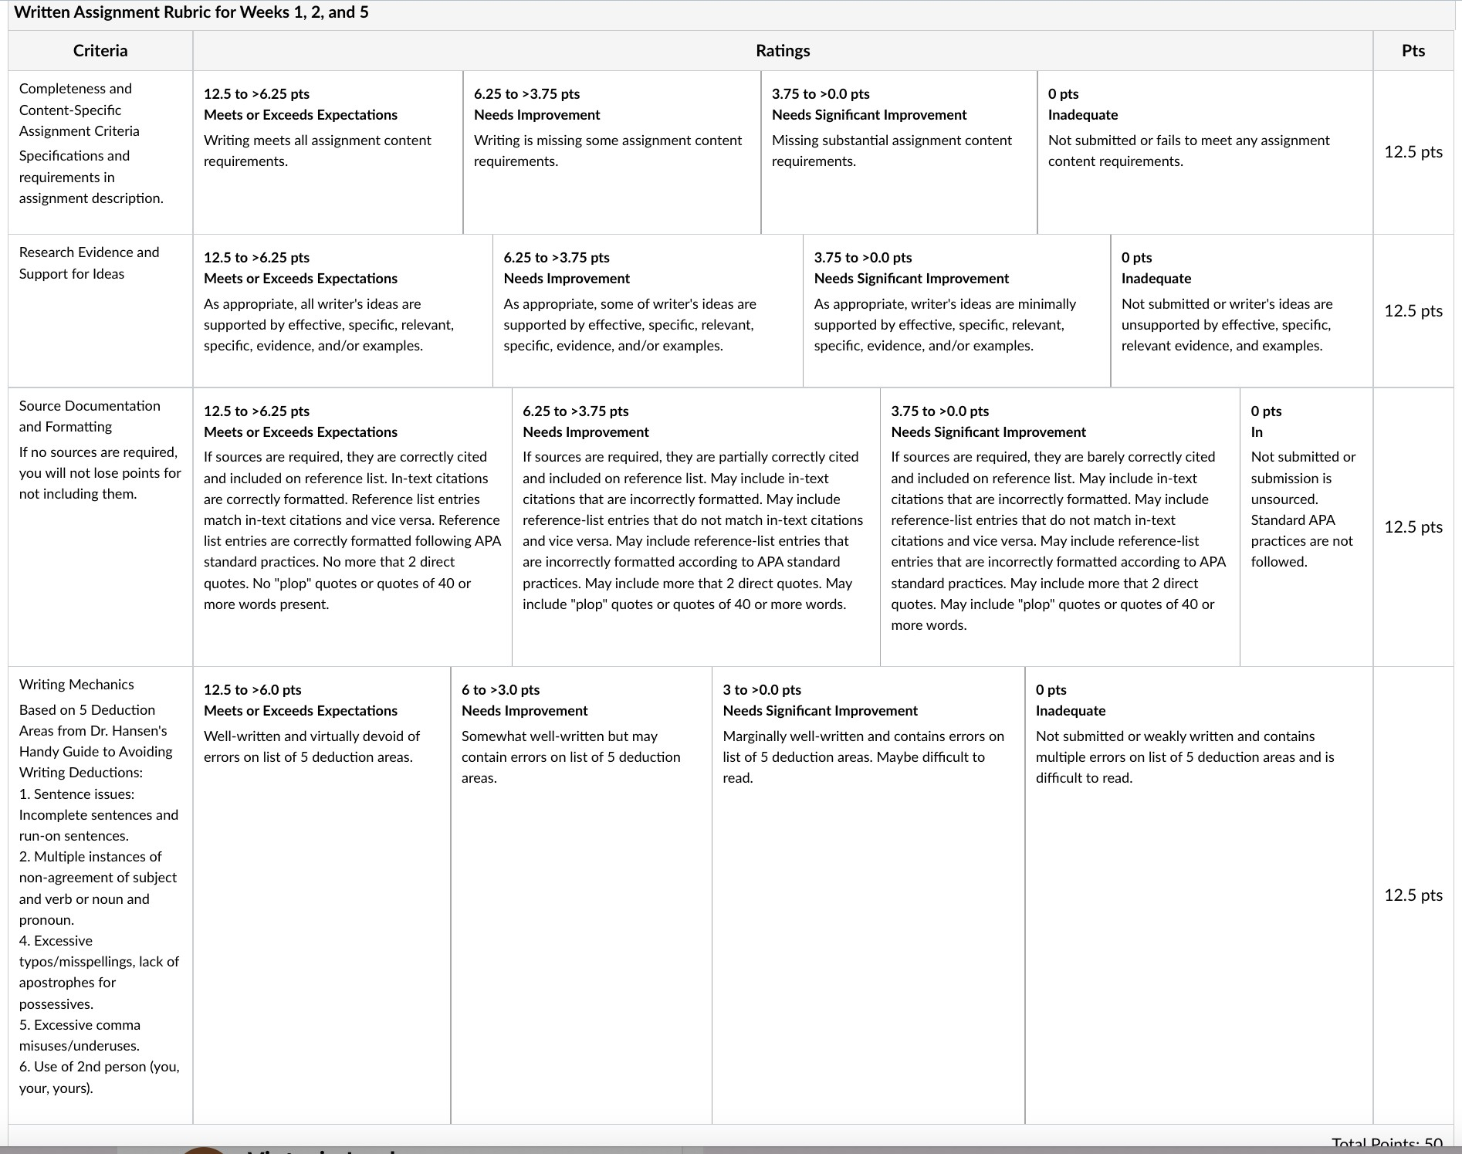

For Week 3 Assignment
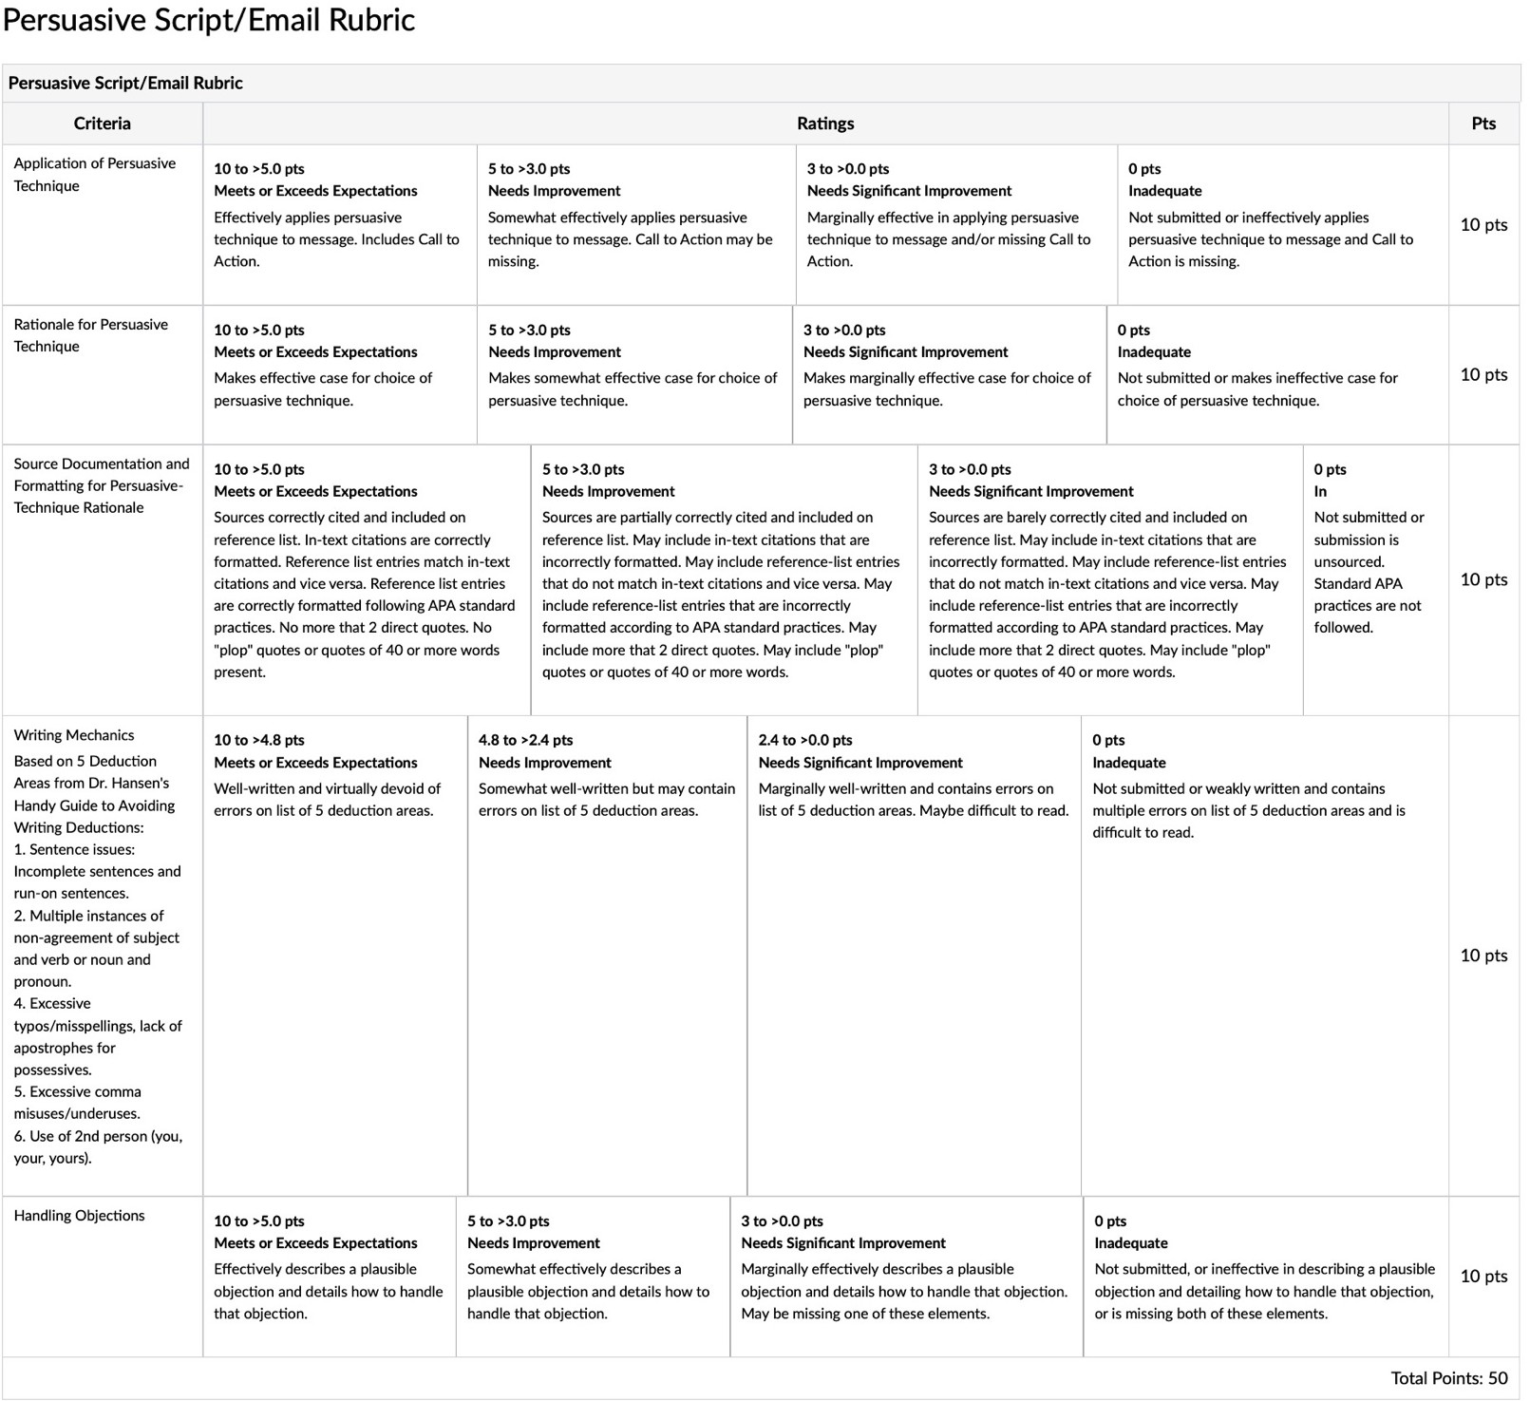

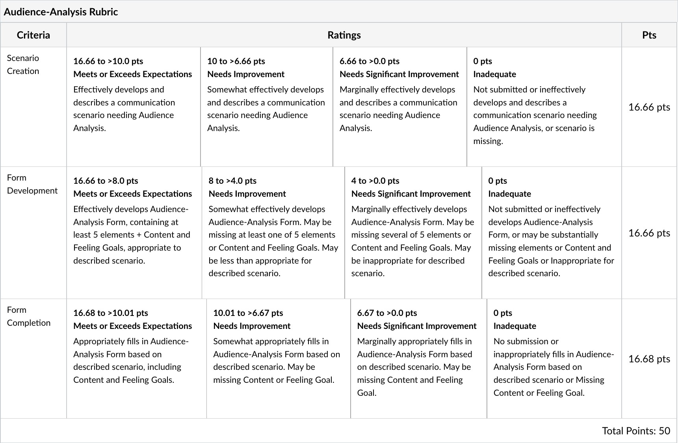
For Week 4 Assignment

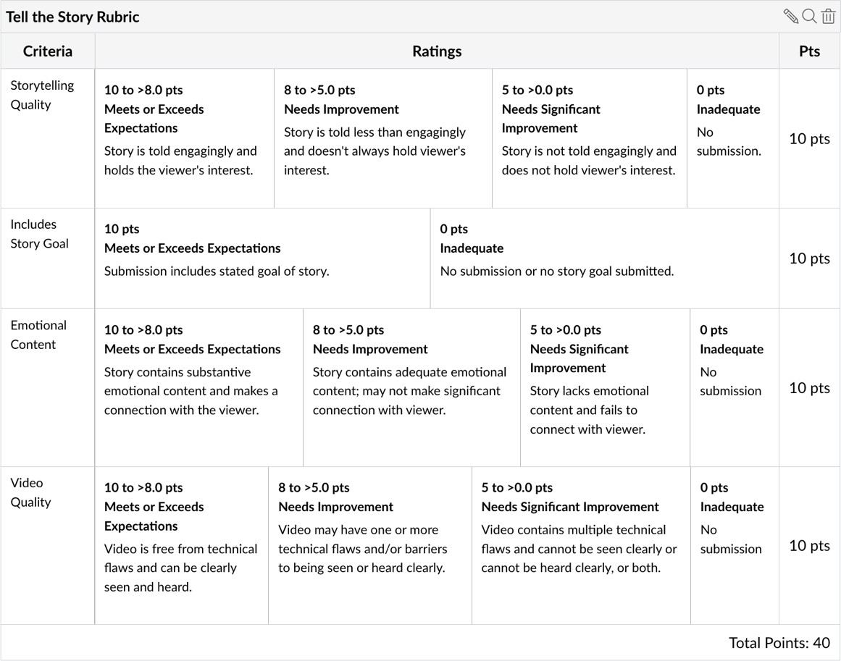
For Week 5 Assignment (Note: Combined Week 5 Assignment (40 points) + Peer Review (10 points) = 50 points

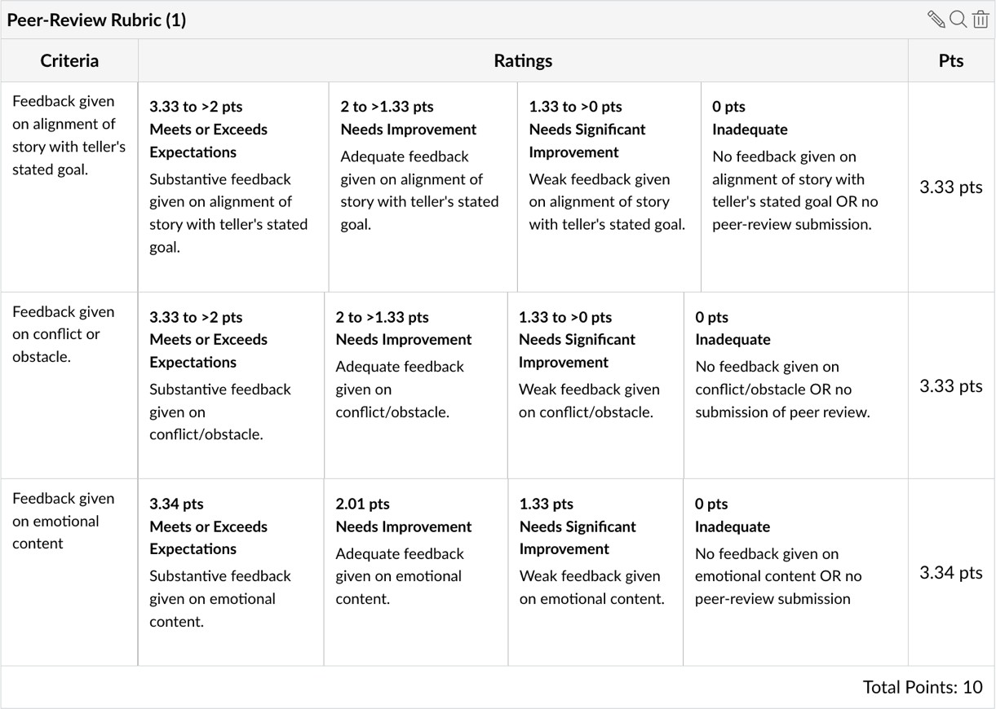
For Peer Review portion of Week 5 Assignment
For Week 6 Assignment
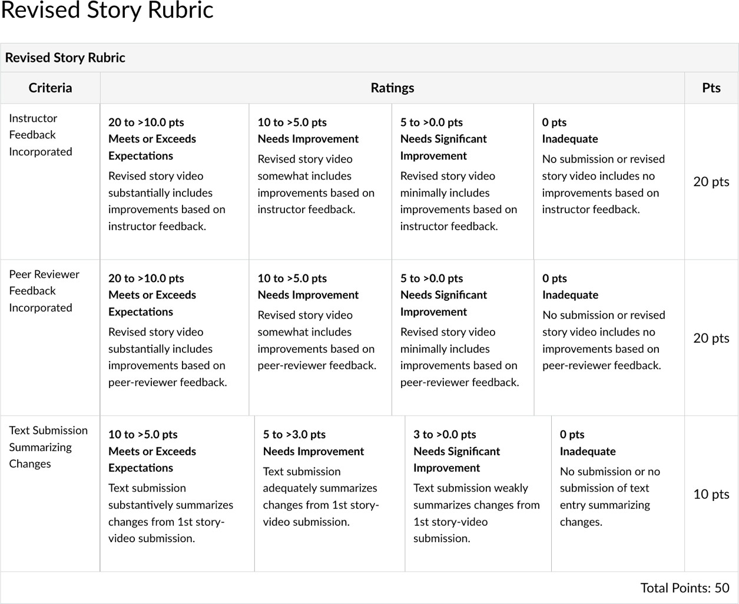

For Week 7 Final Project
