Fall 2023 Genetics 320 Syllabus
TR 11:00am-12:15pm
Lecture Dobbs 124
Lab ( Molecular) Dobbs
Instructor office 212

Dr. Reem Hudaib
Office Hours:
Wednesday 1:00pm-2:00pm
Thursday by appointment
Phone #: 4046443669

e-mail: reem.hudaib@reinhardt.edu
*E-mail is always the best way to contact me

Text (required): Concept of Genetics 12th edition By: Klug, William
2ndery Text: Essential of Genetics 10th edition
Available online on: pearson.com

**Please consider donating to OpenStax in exchange to using their free text so that they can continue making texts like this available at no charge for this and other subjects.

Catalog Course Description:
This is the very basic course in the principles of Genetics and molecular biology. The course is designed to meet the needs of medical and healthcare students including nursing students, physical education majors, sports studies majors, and biology majors preparing for careers in health sciences physician assistant students and Pre-med students.
Plus Providing qualified candidates to work in laboratories as medical technician or scientists to cover the increasing demands of this sector.
*Prerequisite for this course is BIO 120 or permission of the department.

Important:
All students, faculty, staff and administration at Reinhardt University are subject to changes in policies if mandated by the State of Georgia. Current policies and procedures can be found at: https://www.reinhardt.edu/back-to-campus
If you have any questions, please refer to the website or contact Reinhardt University at the numbers below.
- Campus Nurse within the Student Health Center nurse@reinhardt.edu, 770-720-5542 or www.reinhardt.edu/nurse.
- Public Safety - Non-Emergency Phone: 770.720.5789 Emergency Phone: 770.720.5911 publicsafety@reinhardt.edu
- Dean of Students deanofstudents@reinhardt.edu, 770-720-5540
- Office of the VPAA/Provost provost@reinhardt.edu, 770-720-9102

Course Purposes and Learning Objectives:
Material is presented in both lecture and laboratory formats to aid students in developing an understanding and appreciation of the concepts of genetics and human genetics and applying what they learnt in clinical field by doing very basic experiments in Genetics Lab like DNA and other nucleic materials extraction and purification. Understanding the concept of amplification and the importance of using sterile 3techniques in the lab to get the intended outcome and avoid contamination and falsified results, following topics:

The structure of prokaryotic and eukaryotic organisms' cells and the method of reproduction on the cellular level.

The terminology of molecular biology and genetics and names of different organelles on the molecular level of cells.

Part 1

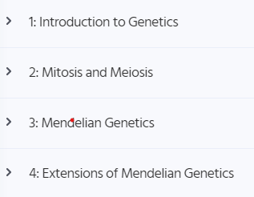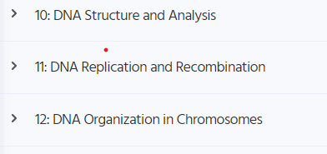

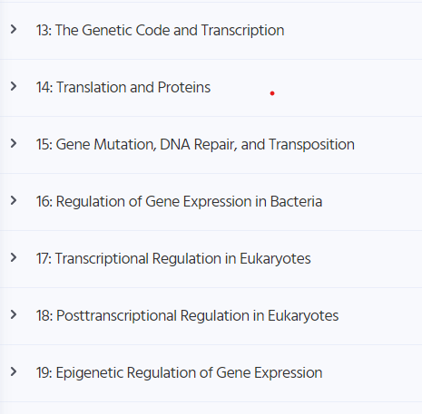

Part 2:

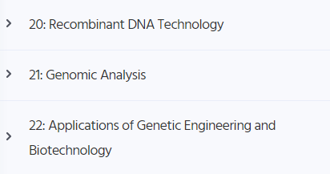
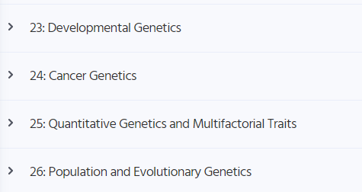

Part 3

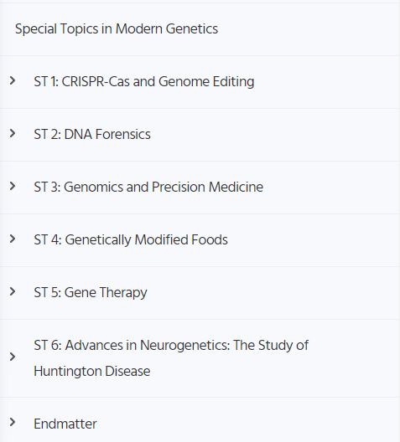

Course Policies: The following regulations must be observed.
1. Attendance is extremely important. You must read and watch lecture videos outside of class before coming into the classroom. We will be doing most of our coursework IN the classroom. If you are unable to attend class for any reason, be sure to contact the professor ASAP to plan to make up any missed work. Note: Coursework can only be done IF you have a legitimate, verifiable, excused absence.
2. You must check Canvas daily for announcements pertaining to class.
3. Each student is expected to speak and conduct himself/herself in a manner that is always respectful and courteous to others (faculty and other students).
4. Reading, Assignment and Exam Policies: Students are expected to complete all assignments, quizzes, exams, etc. on time. No late work will be allowed unless the student has a legitimate, verifiable reason for turning something in late. Please see below:
Acceptable reasons for missing class/exam:
Legitimate reasons for missing a class/exam include any illness requiring a doctors’ visit or hospitalization, or a death in the immediate family. Any other excuses will be considered on an individual basis and the instructor will determine whether the absence will be excused, and the student will be able to make up any work missed due to their absence. Appropriate documentation will be required for an absence to be excused (i.e.-doctor’s note, note from nurse Health Services, obituary notice etc.).
*Note the above says “illness”, regular doctor visits, such as check-ups or physicals, should be scheduled at a time that will not conflict with class. Such visits will not be excused.

5. Academic Integrity
No form of academic dishonesty or student misconduct will be tolerated!
It is an HONOR CODE VIOLATION to cheat or pass information about tests/quizzes from one individual to another. The professor has the right to give both the person who attempts to pass the information and the person who receives the information grade of ‘F’ in the course. Plagiarism is also a violation of this code and will be handled as directed in the University handbook.
6. The use of cell phones is prohibited during class! If you use these devices during class, you may be asked to leave class and will lose your participation points that day. Please be mindful of others and keep your cell phone muted while in class.
7. The use of personal laptops or tablets is allowed during lectures only if they are being used to take notes. DO NOT use these for social media during class! If you use these devices during class time for anything other than taking notes, you may be asked to leave class and you will lose your participation points for that day.
8. You will be held accountable should you break something in the lab due to negligence. In addition, safety equipment (eye washes, shower etc.) are only to be used in the case of an emergency.
9. If the University officially closes on an exam day (see www.reinhardt.edu for official
cancellation or delay notices), the exam will be given during the next regularly scheduled class.
10. If an emergency occurs and the instructor is not present for a designated class or lab session the student is expected to remain in the class or lab room for 15 minutes or until they are notified that the session has been cancelled. The student should use this time for group study or review of assigned material.
11. If you are a student with a disability and require special accommodation to complete
this course, please see the instructor and contact the Academic Support Office (ASO).
The Americans with Disabilities Act (ADA) is a federal anti-discrimination statute that provides comprehensive civil rights protection for persons with disabilities. This legislation requires that all students with disabilities be guaranteed a learning environment that provides reasonable accommodation for their disabilities. Reinhardt University is committed to providing reasonable accommodation for all persons with disabilities. Therefore, if you are seeking classroom accommodations under the Americans with Disabilities Act, you are required to register with the Academic Support Office (ASO). ASO is located in the basement of Lawson Building. To receive academic accommodation for this class, please obtain the proper ASO letters.

Evaluation and Grading:
Attendance, Participation, Professionalism (5%) = attendance, participation and professionalism are important! Be sure to be in class! If you cannot be in class, please email the instructor and arrange to complete any coursework you miss.
Major Exams (70%) =Exams may include multiple choice, True or False, matching and diagrams. There are 3-majort exams (The first 25%, the second 25% and the 3rd is 30% of the final course grade).
*Note: If an exam is missed for ANY reason, it will count as the dropped exam.
Laboratory Component (25%) = Lab participation is measured by lab attendance and participation in individual and small group activities, as well as graded lab assignments and laboratory note assessment (accuracy and precision, details, following the scientific writing method and clearness)

The grading scale is as follows:
A = 90-100%
B = 80-89%
C = 70-79%
D = 60-69%
F = <60%
*This scale is subject to change at the instructors’ discretion. However, do not rely on potential modification of the grading scale (i.e., a curve).

Suggestions for Success:
Watching the lecture videos and taking notes is necessary, as is reading the text!
Study regularly as this is not the kind of course where cramming can lead to a passing grade.
Use multiple resources and study in several diverse ways. Everyone learns differently, and you must find study strategies that work for you. Again, reading and taking notes is necessary, but doing so will not likely be enough to receive a high grade. Review your lecture notes together with the text and re-write your notes as you do so. Try multiple strategies, like diagramming and making your own flash cards. Use the other resources I provide and watch additional videos. Study material multiple times…repetition is key!
If you can draw it, you know it. Pick significant figures from the lectures and text and see if you can re-draw them from memory. It does not have to be pretty to help you a lot!
Make and listen to an audiotape of your notes. Make a tape in your own words and listen to it while doing other things, such as exercising or cleaning.
Collaborate! Getting together with other students (in discussion groups on Canvas for example) for your note-rewriting as review will help you catch details you may have missed the first time through... and will do the same for them.
Also-I am available! If you have questions, do not hesitate to ask!

Center for Student Success (CSS):
The Center for Student Success, in room 035 of Lawson, offers free peer-and- faculty tutoring for all subjects. To make an appointment, contact Charity Robertson or visit the CSS webpage. Be sure to check your emails for more information from Ms. Robertson and the CSS

Tentative Course Schedule
Date Topic Reading Assignment Week 1: week of 8/14
Introduction to genetics and cell structure, following the instructor’s shared materials and the up mentioned guide from the textbook in the order considered in the syllabus.
Lab: Enforcing the major concepts of the lecture's theory

Week 2: week of 8/21 *Last day drop/add is Monday 8/21
Mitosis concept and importance in eukaryotic organisms as a way of replication autosomal cells do to ensure healing and repair mechanism as well as the application of it in human word of transplantation. Lab: scientific method in writing laboratory notes including articles writing method. The significance and appreciation of laboratory PPE especially in genetics lab.

Week 3: week of 8/28
Transcription and Translation to send signals from nucleus to various parts of the body and communicate the orders.
Lab: Theory of molecular experiments and strategies need to be taken to minimize errors and ensure getting the most accurate and précised as well as the importance of reproducibility as a measure of standardization, regulations GLP and reliability.

Week 4: week of 9/4
Transcription and Translation continued
The physiology behind each step-in transcription and translation as a mechanism the body uses to preserve the genetic material from been lost or changed.
Lab: Methods of extraction and purification of nucleic materials and practicing pipetting low volume fluid colored water using the appropriate pipettor and following the exact technique mentioned in SOP, in our case the manufacturer kit instructions.

Week 5: week of 9/11
Pathology of Mutations and Repair Mechanisms.

Lab: continue extractions, basic genetics experiments

Week 6: week of 9/18
Exam 1
Lab: PCR and Gene amplifications using the gel method.

Week 7: week of 9/25
Part 2 as mentioned above in the syllabus. Recombinant of DNA and Biotechnology
Lab: application of genetics biotechnology
Analysis of genetic results using the readers
Discussing modern techniques and how automated systems played a significant role in the development of genetics, availability of diagnostic testing and the widespread of genetics labs all over the world especially after COVID-19 and how diagnostic genetics and biotechnology helped during the Pandemic.

Week 8: week of 10/2
Developmental Genetics
Pharmacogenetics
Cancer genetics

Lab: No Lab
*Fall Break 10/4-6

Week 9: week of 10/9 *Tuesday 10/10-Last day to withdraw and receive W
Exam 2
Covering the part 2 of the syllabus
Lab:
No lab
Fall break

Week 10: week of 10/16
Quantitative methods and Genetic analysis
Population and evolutional genetics

Lab: Copy numbers

Week 11: week of 10/23
CRISPER- CAS and multifactorial traits.
Editing genetics and its application.
Lab: Quantitative PCR Experiment. (qPCR)

Week 12: week of 10/30
Exam 2
Covering the 2nd part, the first chapter from the 3rd art as in the syllabus

Lab: Sequencing and usage of restriction enzymes

Week 13: week of 11/6
Part 3 (continue.)
Gene therapy
Genetics and Cancer
Neurogenetics (Huntington disease)

Lab: Open lab – Study and revision for Practical exam and different applications.

Week 14: week of 11/13
Part 3 continues.
Genetics and Food
Forensic Genetics.
Genetics and Précised Personalized medicine

Lab: Practical exam

Week 15: week of 11/20
Exam 3 (Final Covering the whole material of the course).
Lab: final practical exam.

Have a happy Thanksgiving!

Week 16: continue practical exam

