Reinhardt University
Sport Administrative and Leadership
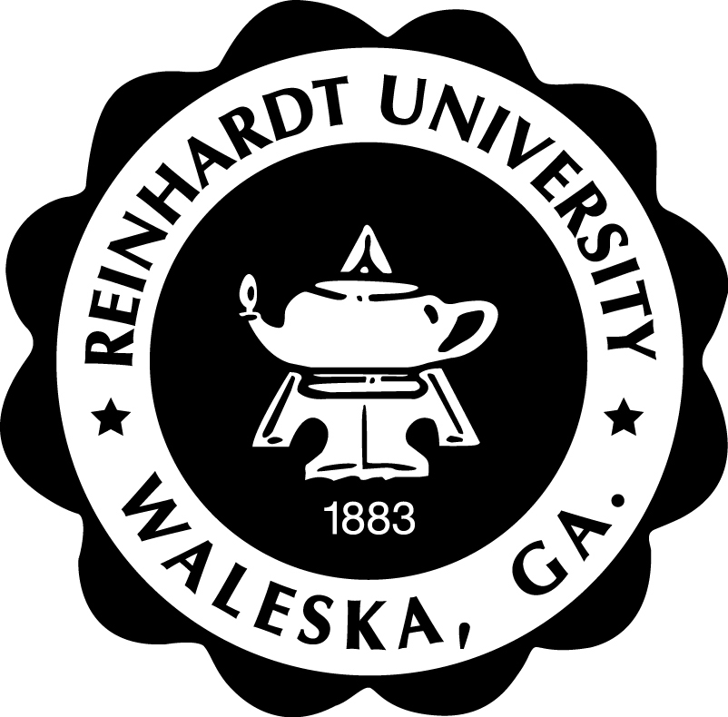
SAL 650: Sport Marketing and Media
(3 Credits)

Course Syllabus - Spring Semester

General Course Information

Class Time/Days: Online via Canvas (Spring Session 1)
Instructor: Dr. Joe Mullins Phone: 770-720-5946
Office Hours: As Posted Email: jwm@reinhardt.edu

Catalog Course Description

Reinhardt Credit Hour Statement; 3 Credit Hour Class (Online)
Over 8 weeks, students will spend a variable number of minutes per week in online lectures, class discussions, and in preparation of class projects and research papers. Instructional time includes a 3-hour final exam. Out-of-class work includes homework and preparation for exams and quizzes and is a variable number of minutes per week (6750 minutes for the semester).

Required Text/Readings

Course Websites
- Website: https://reinhardtuniversity.instructure.com/

Online Course Expectations and Guidelines
- Asynchronous Delivery
  - Students complete the course fully online in asynchronous fashion
    - Meaning students do not have to be online at the same time
- Weekly Forums/Engagement Discussions
  - Instructor provides a weekly discussion topic
  - Students respond to the topic with a forum post or other engagement method (by Thursday of each week 11:55 PM EST)
  - Student reply to discussion posts of at least two classmates (by Sunday each week at 11:55 PM EST)
- Course Assignments
  - Students complete course assignments on dates specified by the instructor
    - Click on “Coursework” portal (left side menu)
  - All submissions are made via the Eagle Web site

Purpose of the Course
The purpose of the course is to provide students with an in-depth knowledge of sport marketing. Students will critically examine key sport marketing principals and theories and how they apply to ever changing sports industry. The class will pay special attention to the concepts of: market research, market segmentation, branding, social media, sponsorships, and global marketing strategy.

Sport Administrative Leadership Program Goal
The mission of the Master of Science in Sport Administrative and Leadership program is to develop leaders and scholars equipped with the theoretical knowledge and practical experience to successfully serve in leadership roles within the sport industry.

Sport Administrative Leadership Program Outcomes
Students graduating with the Master of Science in Sport Administrative and Leadership will:

- Exhibit leadership behaviors consistent with ethical sport administrators

- Apply communication and technology competencies required of sport administrators

- Analyze current and historical issues impacting sport administrators, and integrate solutions to develop positive organizational cultures

- Comprehend the broader role of sport in society

Course Objectives
Students completing SAL 650 Sport Marketing and Media should be able to:
- Analyze and apply sport marketing concepts as they apply to branding, licensing, sponsorships, and global sport marketing.
- Analyze and apply principals of marketing research including database marketing, marketing strategy, and market segmentation.
- Recognize the evolution of social media and how it fits into the sport marketing mix.
- Make data driven decisions based on sport market research.
- Demonstrate an understanding of the interrelationship of integrated marketing communications and sport.
- Understand sport marketing theory and how it can be used in the sport industry to meet the
wants and needs of the sport consumer

Course Requirements/Assignments/Evaluation

Evaluation Procedures
Weekly Discussion and Engagement/Mini Projects | 40%
- Week 1 Discussion Post/Engagement/or Mini Project | 5%
- Week 2 Discussion Post/Engagement/or Mini Project | 5%
- Week 3 Discussion Post/Engagement /or Mini Project | 5%
- Week 4 Discussion Post/Engagement /or Mini Project | 5%
- Week 5 Discussion Post/Engagement /or Mini Project | 5%
- Week 6 Discussion Post/Engagement/or Mini Project | 5%
- Week 7 Discussion Post/Engagement /or Mini Project | 5%
- Week 8 Discussion Post/Engagement/or Mini Project | 5%
Assignments | 60%
- Assignment 1 | 15%
- Assignment 2 | 15%
- Assignment 3 | 15%
- Assignment 4 | 15%
Total | 100%

Grade Scale

- A: 90% and above
- B: 80% to 89%
- C: 70% to 79%
- D 60% to 69%
- F below 60%

Methods of Instruction

Potential methods of instruction and course activities include (but are not limited to):

- lecture and discussion; examinations and quizzes; video and slideshow; presentations; writing assignments; web-based assignments

Academic Integrity

Students are expected to adhere to the Reinhardt Code of Conduct and Honor Code. Violations (including cheating and plagiarism) will result in disciplinary actions.

Accommodation Statement
The Americans with Disabilities Act (ADA) is a federal anti-discrimination statute that provides comprehensive civil rights protection for persons with disabilities. Among other things, this legislation requires that all students with disabilities be guaranteed a learning environment that provides for reasonable accommodation of their disabilities. If you have a documented disability requiring an accommodation, please contact the Academic Support Office (ASO).
Reinhardt University is committed to providing reasonable accommodations for all persons with disabilities. Therefore, if you are seeking classroom accommodations under the Americans with Disabilities Act, you are required to register with the Academic Support Office (ASO). ASO is located in the basement of Lawson Building. Phone is 7707205567. To receive academic accommodations for this class, please obtain the proper ASO letters/forms.
Bibliography

Aiken, K.D., Campbell, R.M., & Koch, E. C. (2013). Exploring the relationship between team (as brand)
personality and geographic personality: Linking consumer perceptions of sports teams and
cities. International Journal of Sports Marketing & Sponsorship, 15(1).

Broughton, D. (2010). Survey: Social-media use builds fan avidity. Sports Business Journal. Retrieved
from http://www.sportsbusinessdaily.com/Journal/Issues/2010/07/20100726/This-WeeksNews/Survey-Social-Media-Use-Builds-Fan-Avidity.aspx

Connor, J., & Mazanov, J. (2010). The inevitability of scandal: Lessons for sponsors and
administrators. International Journal of Sports Marketing & Sponsorship, 11(2), 212-20.

Dekhil, F. (2010). The effects of the type of audience, involvement, interest and
socio-demographic variables on sponsor recall: the soccer African Nations Cup. International
Journal of Sports Marketing & Sponsorship, 11(2), 158-75.

Harris, C., Newman, P., Peck, J., & Willhide, B. (2013). Social media in sport marketing. Scottsdale, AZ:
Holcomb Hathaway Publishing.

Jensen, J. (2012). The importance of winning: An analysis of the relationship between an
athlete’s performance and sponsor exposure during televised sporting events.
International Journal of Sports Marketing & Sponsorship, 13(4), 282-94

Kim, Y., & Kim, S. (2009). The relationships between team attributes, team
identification and sponsor image. International Journal of Sports Marketing &
Sponsorship 10(3), 215-29.

Mikhailitcheenko, A., Tootelian, D., & Mikhailitcheenko, G. (2012). Exploring saturation
levels for sponsorship logos on professional sports shirts: a cross-cultural study.
International Journal of Sports Marketing & Sponsorship, 13(4), 267-81.

Nielsen Sports. (2013, January). The changing face of sports media.
http://www.nielsen.com/us/en/search.html?q=the+changing+face+of+sports+media&sortbySco
re=false

Parker, H., & Fink, Janet. (2010). Negative sponsor behavior, team response and how this
impacts fan attitudes. International Journal of Sports Marketing & Sponsorship, 11(13), 200-1.1

Schlesinger, T., & Gungerich, M. (2011). Analyzing sport sponsorship effectiveness – the
influence of fan identification, credibility and product-involvement. International Journal of
Sports Marketing & Sponsorship, 9(1/2), 54-74.

Schultz, B., Caskey, P. H., & Esherick, C. (2010). Media relations in sport (3rd ed.). Morgantown, WV:
Fitness Information Technology.

Solis, B. (n.d.). The roles of the social consumer. [graphic] Retrieved from
http://www.flickr.com/photos/briansolis/530334081 (see Module 7)

Tribou, G. (2011). Sponsorship: Associating image attributes with specific sports and
particular teams. International Journal of Sports Marketing & Sponsorship, 12(2), 138-522.

Walker, M., Hall, T., Todd, S. & Kent, A. (2011). Does your sponsor affect my perception of the event?
The role of event sponsors as signals. Sports Marketing Quarterly, 20, 138-47.

Wang, R.T., & Kaplanidou, K. (2013). I want to buy more because I feel good: The effect of sport-induced
Emotion on sponsorship, International Journal of Sports Marketing & Sponsorship 15(1).

SAL 650 Tentative Course Outline and Calendar
Date | Topic | Due
Week 1 | - Welcome to Course  - Intro to sport marketing and media  - Understanding the Sport Product | - Discussion Post 1
Week 2 | - Strategic Sport Marketing | - Discussion Post 2  - Assignment One
Week 3 | - Understanding the Consumer | - Discussion Post 3
Week 4 | - Sport Market Research | - Discussion Post 4  - Assignment Two
Week 5 | - Branding | - Discussion Post 5
Week 6 | - Social Media and Creative Media | - Discussion Post 6  - Assignment Three
Week 7 | - Sport Sponsorships | - Discussion Post 7
Week 8 | - Developing a marketing plan | - Discussion Post 8  - Assignment Four

NOTES AND REMINDERS
- All Dates/topics are tentative and subject to change based on pace of course
- Readings should be completed by the dates listed in the right column on the calendar
- Please inform instructor immediately if you have concerns or problems with assignments

