Syllabus – Spring 2023
PSY 360 010 MC
Behavior Analysis
Spring 2023: Mon/Wed: 01:30p – 2:45p
W Frank & Evelyn J Gordy Center,
Gordy Seminar 1

Instructor: Dr. Susana Solomon
E-mail: Susana.solomon@reinhardt.edu

Office Location: Tarpley 205
Visiting Office Hours: MW: 8a-9a, 10a-11a, 12p-1p
Link to my calendar to schedule an appointment - https://calendly.com/susana-solomon
Walk-ins are also welcome

Preferred method of communication: Email is the preferred method of communication. I usually respond to inquiries within 24 (M-F) and within 36 hours over weekends and/or holidays. ‘Ask the Instructor’ discussion board can also be used to post general questions related to the material.

Welcome to PSY 360 Behavior Analysis. I will be your instructor for this class. I have been working in and studying psychology for the last 20 years. I took my first psychology class as a dual-enrolled student in high school. I have always been intrigued by this subject matter. I enjoy seeing students discover that psychology has so many applications for everyday life, from memory tricks to environmental factors that influence human thought and behavior (sociology). I think you will be surprised at how often you will find yourself using information from this course in your day-to-day activities. I hope this course challenges you to critically analyze your environment and your own persona. Some of the material will stir curiosity, confusion, disagreement, and other various emotions. Bring your questions to class where we can further dive into the material collectively. I look forward to working with you this semester.

Required Textbook
The required textbook is: Powell, R., Honey, P., Symbaluk, D. (2023). Introduction to Learning and Behavior (6th ED). Cengage.

Use the link below to purchase ebook -
https://www.vitalsource.com/products/introduction-to-learning-and-behavior-russell-a-powell-p-lynne-v9780357658512

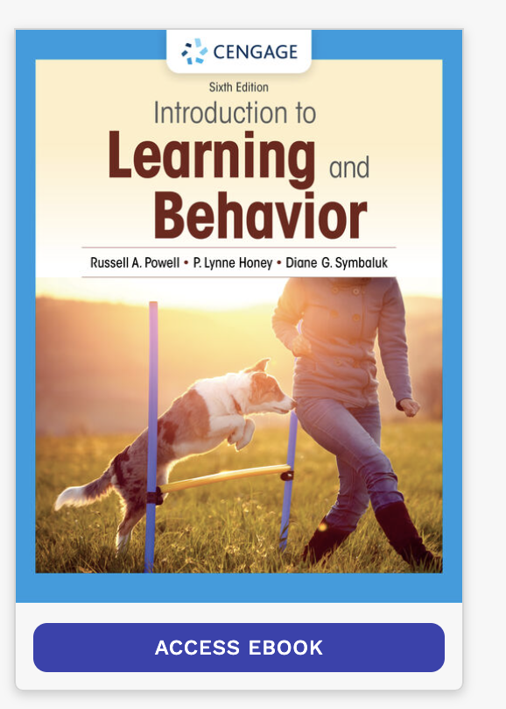

Course Description and Objectives

The principles of behavior analysis and learning will be applied to problems in shaping and managing human behavior. The techniques covered will include: operant and classical conditioning, reinforcement of successive approximations, schedules of reinforcement, operant and classical extinction, reinforcement of competing responses, counter conditioning, negative reinforcement and stimulus control. These procedures will be related to a range of practical settings and applications.
Please keep in mind that this is a 3-credit hour course. As such, you can expect to spend about 7.5 hours total (including class time) completing coursework.

Learning Objectives:

This course introduces the psychology major to classic theories of learning and cognition as well as the contemporary application of these principles. Classes will include lecture with discussion, activities, and out-of-class exercises. As a part of the class, students will practice writing in APA 6th edition format.

After completing this course, you should be able to:
a) identify and use the basic terminology of classic learning theories
b) compare and contrast reinforcement and punishment
c) compare and contrast classical and operant conditioning
d) discuss the application of learning principles in contemporary settings
e) evaluate the methodology and design of published psychological research
f) use library resources to find references for a topic in psychology

Verification: Students will demonstrate competence in these areas through:
1. Regular participation and being prepared to discuss questions based on lecture material and text readings.
2. Obtaining an overall average grade of C or better for the coursework.

Integration of Course and Psychology Program Student Learning Outcomes (SLOs)

Program SLOs
- Content & integration 2. Research methods 3. Communication 4. Ethics

- identify and use the basic terminology of classic learning theories ____1, 3___
- compare and contrast reinforcement and punishment ___1, 3 __
- compare and contrast classical and operant conditioning ____1, 3___
- discuss the application of learning principles in contemporary settings ____1, 3, 4___
- evaluate the methodology and design of published psychological research _1, 2, 3, 4___
- use library resources to find references for a topic in psychology ___2, 3___

Integration of Course and School of Math & Sciences Student Learning Outcomes (SLOs)

School SLOs

1 Roles of Research & 2 Participation 3 Professional
Theory in Science in Research Preparedness

- identify and use the basic terminology of classic learning theories ____1___
- compare and contrast reinforcement and punishment ___1 __
- compare and contrast classical and operant conditioning ____1___
- discuss the application of learning principles in contemporary settings ____1, 2, 3___
- evaluate the methodology and design of published psychological research __1, 2, 3___
- use library resources to find references for a topic in psychology ____1, 2, 3___

Reinhardt University Student Learning Outcomes

Communication: Corresponding Course SLO’s a, b, c, d, e
Students will demonstrate:
- Effective expression of ideas through writing, speech, and visual media.
Critical Thinking and Inquiry Corresponding Course SLO’s a, b, c, d, e, f
Students will demonstrate:
- Integrative, critical thinking and inquiry-based learning using evidence, logic, reasoning, and calculation.
- Knowledge of various research methodologies, information, technological, and scientific literacy.
- Independent thought and imagination; preparation for lifelong learning.
Values and Ethics Corresponding Course SLO’s: e
Students will demonstrate:
- Integrity and ethical responsibility.

Assignments

(2) Article Critiques (20 percent of final class grade)
There will be two supplementary readings of scientific articles. For each article, students must write a critical evaluation of the article. The critical evaluation should include and APA reference for the article, a brief summary of the article (similar to an abstract and no more than 120 words), a critical evaluation of the strengths of the article, and an evaluation of the weaknesses of the article. Details about the specific format for the critique and issues relevant to the way the assignment will be evaluated will be discussed in class. Scheduled discussion dates are indicated on the schedule. It is expected that all students will have read each assigned article before the course period dedicated to it. Students not present during these discussions will be held to the same standards upon which all other students are evaluated. The two critiques are worth 50 points each toward your final grade.

Weekly Chapter Quizzes (24% of final class grade)
The course material is divided into 14 chapters and, consequently, 14 quizzes. The lowest two attempts will be dropped from final grade; therefore, only 12 quizzes will count towards final grade. You will be required to complete a quiz during each unit according to the schedule listed in this syllabus. All quizzes will be delivered online in CANVAS and links to each quiz will be available in the appropriate learning module folder. Late attempts will not be accepted. Please be sure to complete all assignments on time. Each quiz is open book/open notes, and consists entirely of multiple-choice questions. Additionally, all quizzes will be timed – you will have 60 minutes to complete each quiz. Note: You will not be allowed to submit or revise any your answers once the time limit is reached

Intervention Proposal Paper (36% of final class grade)
Topic (0 points). You will identify a behavior of another person, animal, or group that you would like to change (increase or decrease). I must approve your topic IN ADVANCE (due date is listed in course schedule for topic). Your topic submission should include an operational definition of the behavior you wish to change, who’s behavior it is, how you will collect data on the behavior, and a general idea of how you might change it. Note: although this is not worth any points, you will not receive ANY credit for your final paper if your topic is not approved.

Intervention Proposal Paper (80 points).
You will create a written (in APA style) proposal to address your topic using intervention techniques learned in this class. The proposal should be 8-10 pages (2000-2500 words), not including title page, references, or figures. A required rough draft is due by the date listed on the course schedule. The draft will be ungraded and it is highly recommended that you incorporate any feedback in your final paper. Please use the writing center for any review of formal writing. The paper is worth 80 points. Due dates are listed on the course schedule. You will lose 10% (8 points) for each day late. In addition, you must turn in the proposal in order to pass the course. In other words, if you do not turn in the proposal paper, you will automatically receive a grade of “F.” Detailed instructions and rubric are at the end of this document. The basic structure/content of the paper is as follows:

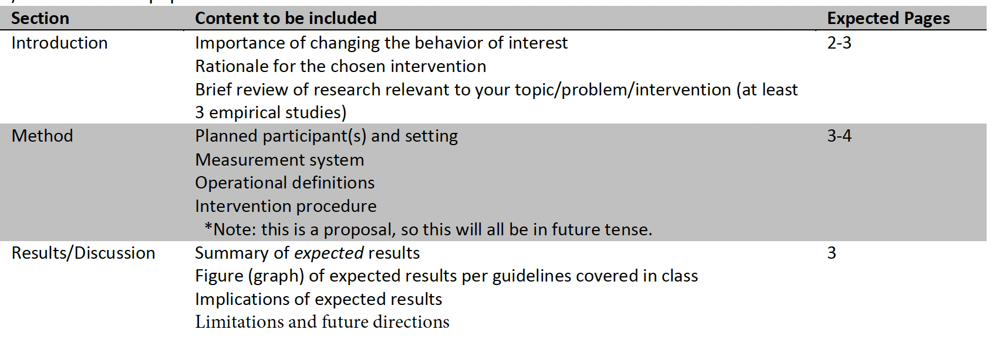

Peer Review Sessions (10 % of final class grade)
You will have two opportunities for peer review of your proposal throughout the semester. During these sessions, we will break the class into small groups (2-3 students). Each student will present his or her topic and intervention plan to the group. It is required that you bring an outline (a physical document) of your planned project. The group will provide feedback and suggestions. Students will earn up to 10 points per session in the peer review process (5 points for the outline and 5 points for active peer review participation). Active participation is defined as making as least two substantive comments about another person’s intervention proposal during the review session on an evaluation form (form at the end of this document). These participation points will be counted separately from general attendance and participation points.

In Class Participation (10% of final class grade)
In general, course grades should reflect student’s mastery of material and not the ability to simply be present. Having said this, attendance (and more importantly active participation) is critical to success in my classes. You are expected to attend class, be present for the full class period, and have read the assigned material before you come to class. Lectures will cover material that is not in the book but will be on the test. Students are responsible for all material covered in the lectures and in the book. Students will be responsible for material missed when absent.

A portion of your grade (100 points) will be based on writing assignments, quizzes, and activities. Participation assignments will vary in their value. Points will accrue until a maximum of 100 is reached. I will provide more than 100 points worth of opportunities; however, you will not have the opportunity to make-up activities that are missed due to absence, leaving early, or arriving late. These assignments are not busy work. Each one is intended to help you integrate and apply the concepts that you are reading about in your text. You should expect to have some activity (or activities) each day. Assignments may be given at any point during class and are not listed in the syllabus, will not be announced in advance, and will not be posted online. If you miss a participation assignment for whatever reason, you cannot make it up. Late assignments (i.e., those offered after I have already collected the assignment from the rest of the class) will not be accepted and will earn no credit. Assignments cannot be turned in by email.

Final Exam –
We will not have a final exam for our class.

Course Policies

Class Method and Participation:
In order to create the most effective classroom experience, I encourage all students to actively participate in class, including contributing to discussion, asking questions, and responding to ideas presented in class. This type of active participation is both a better way to learn and a lot more interesting than simply listening to lectures! I do understand that students can sometimes feel anxious to speak up in class (I was there too). If this applies to you, please feel free to come talk to me. I have strategies that worked for me and I would be happy to share them with you!

Please note that participation during classes is intended to be a learning activity. Your comments in class are not expected to always be correct. Making mistakes is a part of the learning process! Some of this material is complex and a certain degree of confusion, uncertainty, or misinterpretations is to be expected. In addition, sometimes there will not be “right” or “wrong” answers – just points of view. So, please do not be afraid to share your thoughts during class. However, I do expect all students to be respectful of others’ views. Remember, we all come from different walks of life.

Classroom Environment
In order to learn, we must be open to the views of people different from ourselves. In this time we share together over the semester, please honor the uniqueness of your classmates, and appreciate the opportunity we have to learn from one another. Please respect each other’s opinions and refrain from personal attacks or demeaning comments of any kind. Finally, remember to keep confidential all issues of a personal or professional nature that are discussed in class.

Attendance
Attendance is highly encouraged, and regular studying and active participation will be rewarded. Every day, I will ask review questions, class participation questions, and other sorts of questions to enhance your learning and understanding of the material. Review questions will come from the text and the notes, and will be graded on correctness; the other questions will be graded on participation. There are opportunities for extra credit throughout the semester, but you must be in-class to receive credit. I will be using a sign-in sheet or QR code at the beginning/end of each class to track attendance.

Late Work / Missed Deadlines
Missing any of the assignment deadlines listed herein may prevent your successful completion of the course. If you foresee difficulty of any type (i.e., hospitalization, employment change, etc.) that may prevent completion of this course, please notify me as soon as possible with an explanation. I understand life happens and I will gladly work with you to troubleshoot the issue. If warranted, I will re-open an assignment and you will be required to complete the assignment within 24 hours of the time stamp on my reply to your email message.

Plan to complete all course discussions, assignments, and assessments at least several hours prior to the posted deadlines. By electing to wait until the "last minute" to complete these assignments, you may invoke Murphy's Law ("If anything can go wrong, it will"). There are no extra credit opportunities in this class. However, as mentioned early on in the syllabus, the lowest scores on 7 launchpad assignments and 2 launchpad quizzes will not count against your final grade. This “extra cushion” was intended to alleviate some stress when life-situations happen. If you ever have a question or concern (no matter how small or complex), I am only an email away and I am more than happy to lend a hand or a listening ear.

Grade Appeals / Policy
If, for any assignment, you feel that the grading policy was unfair in some way, then you must make your case to me in writing via email. I will not respond to verbal complaints about grades. These emails must be received within one (1) week of the posting of your grade; do not wait until the end of the semester.

Once computed and verified, all course grades are final and will not be changed. Every semester, a student approaches me with a request that I raise his or her grade (because she or he will be placed on probation, because he or she will lose their Hope scholarship, because she or he won't be able to graduate as planned… or be accepted into graduate school, & etc.). Please do not ask me to change your grade and know that I have never adjusted a student's grade for any of those reasons. Doing so would be unethical on my part and unfair to other students enrolled in the class.

Incomplete Grades
A grade of “I” indicates an incomplete grade for the course, and will be awarded only when the student has done satisfactory work up to the last two weeks of the semester, but for nonacademic reasons beyond his/her control is unable to meet the full requirements of the course. In other words, the grade of “I” is only awarded for emergencies and not for academic difficulty.
The specified time limits to have an “I” grade removed are as follows:
- The course requirements must be completed, as agreed upon between the student and the faculty member, by the end of the next semester or term student is enrolled in order for the grade of “I” to be removed.
- If the student fails to enroll within one calendar year from the end of the semester or summer term in which the “I” was originally assigned and does not complete the course requirements, then the “I” will be changed to an “F”.
The “F” grade is assigned for a course which awards letter grades of “A”, “B”, “C”, “D”, or “F”) and the cumulative and adjusted grade point average will be recalculated accordingly or, the “I” will be changed to a “U” (for a pass/fail course which awards a grade of “S” or “U”).
Upon completion of the course requirements within the specified time limits, a final grade will be assigned on the basis of the student’s total performance. An “I” cannot be removed by re-enrolling in the course.

Plagiarism and Cheating
According to the Student Code of Conduct: No student shall receive, attempt to receive, knowingly give, or attempt to give unauthorized assistance in the preparation of any work required to be submitted for credit (including examinations, laboratory reports, essays, themes, term papers, etc.). Unless specifically authorized, the presence and/or use of electronic devices during an examination, quiz, or other class assignment is considered cheating. Engaging in any behavior which a professor prohibits as academic misconduct in the syllabus or in class discussion is cheating. When direct quotations are used, they should be indicated, and when the ideas, theories, data, figures, graphs, programs, electronic-based information or illustrations of someone other than the student are incorporated into a paper or used in a project, they should be duly acknowledged. No student may submit the same, or substantially the same, paper or other assignment for credit in more than one class without the prior permission of the current professor(s).

AI Use Allowed, but Not Required:
In this class, you are welcome to use AI for any purpose. However, you should note that all AI generative tools still tend to make up incorrect facts and fake citations, code generation models tend to produce inaccurate outputs, and image/art generation tools can produce copied work or offensive products. You will be responsible for any inaccurate, biased, offensive, or otherwise unethical content you submit regardless of whether it originally comes from you or an AI tool. If you use an AI tool, its contribution must be credited in your submission. The use of an AI tool without acknowledgement is cheating and constitutes a violation of the KUS Code of Academic Integrity.

Religious/Cultural Observances
I want to ensure that I honor your ability to engage in any religious/cultural observances that are not included in the Reinhardt U. calendar. If there are religious/cultural observances that may impede your ability to complete an assessment prior to the due date, please reach out to me in advance and we can discuss alternative options. If I am contacted after a deadline has passed, no exceptions will be made.

Evaluation and Grading Policies
I generally post all grades within one week of an assignment’s due date. Final course grades will be available in CANVAS and on your online transcript. Grades will not be provided via phone, email, or other electronic means, and will be assigned as follows:

Graded Activity | Percentage
Weekly Quizzes (12/14) | 24
Article Critiques | 20
Peer review of proposal | 10
Intervention proposal paper | 36
Class activities | 10
Total Possible Points | 100

Grading Scale | Description
A (90 – 100%) | Excellent
B (80 – 89%) | Very Good
C (70 – 79%) | Average
D (60 – 69%) | Below Average
F (59% or Lower) | Failing

I will round up grades if they are > or = .5 or above, for example, an 89.6 is an A, but 79.2 is a C.

General University Administrative Policies

This section contains policies that apply to all courses and are set forth by the University. All policies are detailed in the Academic Catalog (and those policies shall apply).

University Covid 19 Statement: Important: All students, faculty, staff and administration at Reinhardt University are subject to changes in policies if mandated by the State of Georgia. Current policies and procedures can be found at: https://www.reinhardt.edu/back-to-campus

If you have any questions, please refer to the website or contact Reinhardt University at the numbers below.
Campus Nurse within the Student Health Center

nurse@reinhardt.edu, 770-720-5542 or www.reinhardt.edu/nurse.

Public Safety
Non-Emergency Phone: 770.720.5789
Emergency Phone: 770.720.5911
publicsafety@reinhardt.edu

Dean of Students
deanofstudents@reinhardt.edu, 770-720-5540

Office of the Provost
provost@reinhardt.edu, 770-720-9102

College Policy on Attendance: In accord with the Reinhardt College Academic Catalog, regular attendance at scheduled classes and examinations is each student’s obligation. Regarding excused absences as defined in the Catalog it is the responsibility of the student to have the excuse approved by the instructor before the absence and to complete all of the assignments. Emergency absences as defined in the Catalog are excused at the discretion of the instructor and only if the student makes his or her situation known immediately upon returning to class.

College Policy on Withdrawals: If a student drops a course during the first week of classes, the course will not be reflected on the transcript. After this, students may formally withdraw from a course and receive a grade of W up until the date set in the Academic Calendar. It is the student’s responsibility to complete the necessary steps to officially withdraw from the course. This institution does not have instructors complete “administrative withdrawals” for non-attendance. Therefore, if it is your intention to drop a class, you need to complete the required steps to formally withdraw from the course. The student is responsible for understanding the implications that may occur from dropping one or more courses (examples: financial aid, housing, health and/or auto insurance eligibility, and others).

Notice of ADA: If you have a disability which may require assistance or accommodation, or if you have any questions related to any accommodations for testing, note takers, readers, etc.; please speak with me as soon as possible.

The Americans with Disabilities Act (ADA) is a federal anti-discrimination statute that provides comprehensive civil rights protection for persons with disabilities. This legislation requires that all students with disabilities be guaranteed a learning environment that provides for reasonable accommodation of their disabilities. Reinhardt University is committed to providing reasonable accommodations for all persons with disabilities. Therefore, if you are seeking classroom accommodations under the Americans with Disabilities Act, you are required to register with the Academic Support Office (ASO). ASO is located in the basement of Lawson Building. To receive academic accommodations for this class, please obtain the proper ASO letters.

Center for Student Success: The Center for Student Success (CSS) is located on the upper (top) floor of the library, Room 313. CSS offers free peer and faculty tutoring for all subjects. For appointments, go to Reinhardt webpage and click Center for Student Success.

Academic Integrity: Academic dishonesty and penalties as defined in the Academic Catalog will be strictly enforced. All acts of academic dishonesty will be reported to the administration.

All students are expected to adhere to the highest standards of academic integrity, and to abide by the Reinhardt Honor Code. Also, all students are expected to be familiar with the Reinhardt policy on academic dishonesty stated in the University Catalog and in the Student Handbook. Plagiarism (using the ideas and phrases of others without crediting them, therefore claiming those ideas and phrases as your own) will not be tolerated in this course or on this campus. To avoid such academic dishonesty, you must use a citation (footnote or in text) for all ideas drawn from your reading and research, including research in encyclopedias and online, even when you have restated those ideas in your own words.

Consequences for cheating or plagiarizing:

a) I expect all students to uphold the highest standards of academic honesty and integrity. Acts of academic dishonesty include plagiarism, cheating, unauthorized collaboration, and falsification. Working together with classmates is acceptable and even encouraged, but all assignments submitted for a grade should reflect your own efforts (and writing). It is fine to discuss questions and topics with your peers, is it academic dishonesty to copy someone’s work (this includes information from the internet that is not properly credited). The penalty for academic misconduct in this course varies from a 0 on the assignment to a failing grade in the course, depending on the severity of the offense and the student’s history of academic conduct. Disciplinary action may be taken in addition to the academic penalty if the instructor, department, or college feels such action is warranted.

b) The Office of the Vice President for Academic Affairs will be notified of actions taken against students who violate the academic integrity policy, which may result in further consequences, including designation of “academic warning” on your official transcript, academic suspension, or expulsion for academic reasons.

Additional Administrative Policies

Participation and Assessments Policy:
- Students are expected to attend all class meetings and/or participate as required for this class.
  - It is the responsibility of the student to account for instructional time missed and to gather and present the proper documentation for make-up work allowed at the discretion of the instructor.
- Student Athletes – It is strongly encouraged to complete assignments/quizzes/exams before their due date if you have an upcoming game/event. Planning ahead is planning for success! I understand you may miss class due to games/events. I take attendance for tracking purposes. You do not need to submit an excuse or note for missed class. You are ultimately responsible for any notes or information missed. Some of our exams are IN-CLASS. As such, be sure to pre-arrange with the instructor (me) a time to make up the exam BEFORE the exam due date.
- Assessments include, but are not limited to: tests, quizzes, assignments, discussion boards, course activities, midterms, and finals.
- Students are expected to arrive no later than the scheduled start of class time for on-campus assessments. No tests will be given out after the first student has completed and turned in their test.
- Students are expected to complete all assessments prior to the due date and time assigned by the instructor.
  - Any assessments that are not submitted prior to the due date / time will be graded as a zero. No late assessments are accepted.
  - Online assessments will open and close during the availability period set by the instructor.
  - Students will need a reliable computer and internet access for assessments.
  - The following are NOT considered valid excuses to miss any assessment.
    - Did not know availability date / time / deadline.
    - Did not read emails or announcements.
    - Failure to obtain textbook.
    - Scheduled vacations, sporting events, voluntary obligations, work-related activities, external school activities, transportation issues and other similar situations.
    - Inadvertent keystrokes.
    - Incompatible web browsers.
    - Attempts on mobile devices.
    - Loss of internet / computer / email access.
    - Other user-related technical difficulties.
- Assessments will be issued by the instructor and student participation is required.
  - No assessments will be delivered before or after the scheduled availability period.
  - Assessment notifications may be announced during class meetings, emailed to students, or posted in CANVAS Announcements.
  - It is the responsibility of the student to attend all scheduled classroom meetings, read announcements and emails, check college e-mail accounts daily, and be present for all course assessments.
  - Instructors are not required to provide advance notification of in-class assessments.
- Students anticipating an unavoidable situation beyond their control that prevents them from completing assessments as scheduled should contact the instructor in advance and provide supporting documentation as soon as possible.
- If the student does not submit assessments as scheduled by the instructor a grade of zero will be issued.

In the case that a student unavoidably misses an assessment delivered in class or online, to be considered eligible to complete the missed assessment, the student MUST:

- Inform instructor of circumstances immediately upon return from absence (or within 48 hrs. of expiration of due date of missed assessment) and request an opportunity to complete the missed assessment.
  - If a student fails to inform instructor and requests an opportunity to complete the missed assessment within 48 hours of the missed assessment due date, the instructor may deny the student’s later request.
- Establish that the absence or failure to submit the assessment was caused by an unavoidable situation that was beyond the control of the student.
  - Scheduled vacations, travel, voluntary obligations, work-related activities, transportation issues and other similar situations are not considered beyond the control of the students.
  - Assessments will not be rescheduled to accommodate planned or voluntary absences by the student.
  - Technical difficulties (including but not limited to: internet interruption, unavailability or unreliability, inadvertent key strokes, failure to access email, incompatible web browsers, failure to successfully access Canvas or other third-party learning management systems, attempts on mobile devices, and other user-related technical problems) will not be considered valid excuses for failure to complete assessments on time.
  - Present documentary, dated, verifiable evidence provided by an independent, professional source that establishes student was unable to complete the missed assessments throughout the entire period of assessment availability.
  - This source may be a doctor, government agency, or a professional organization or institution.
  - Documentation must be on full-page professional letterhead with contact information. Any privileged information may be redacted. The documentation must clearly show a range of dates for which the student is claiming an excused absence.
  - Accommodations for chronic illness can be provided, if approved by the university. Students may apply for accommodations by contacting the Academic Support Office. Without approved accommodations, instructors may not offer make-up dates for assessments missed.
  - Statements by students, family members, friends or associates, are not considered documentary, verifiable evidence provided by an independent, professional source.
In the event the student immediately informs the instructor of the absence and requests an opportunity to complete the assessment, establishes that the absence was unavoidable and presents supporting, documentary evidence, the student may, at the instructor’s discretion, be allowed to complete the missed assessment(s). This assessment(s) should be completed by the student no later than the next class meeting, due date of the next assessment, or at a time scheduled by the instructor.

Course Schedule

Week 1- January 8th
Review of Chapter 1: Intro to Historical Background & 5 Schools of Behaviorism
JOURNAL: Hanley, G. P., Heal, N. A., Tiger, J. H., & Ingvarsson, E. T. (2007). Evaluation of a class wide teaching program for developing preschool life skills. Journal of applied behavior analysis, 40(2), 277–300. https://doi.org/10.1901/jaba.2007.57-06

- Chapter 1 Quiz due January 14th

Week 2 – January 15
Review of Chapter 2: Research Methods
JOURNAL: Baer, D. M., Wolf, M. M., & Risley, T. R. (1968). Some current dimensions of applied behavior analysis. Journal of applied behavior analysis, 1(1), 91–97. https://doi.org/10.1901/jaba.1968.1-91

- Chapter 2 Quiz Due January 21st
- Topic selected and approved Intervention Paper by Dr. Solomon NLT January 21st

Week 3 – January 22
Review of Chapter 3: Elicited Behaviors & Classical Conditioning
JOURNAL: DeLeon, I. G., & Iwata, B. A. (1996). Evaluation of a multiple-stimulus presentation format for assessing reinforcer preferences. Journal of applied behavior analysis, 29(4), 519–533. https://doi.org/10.1901/jaba.1996.29-519

- Chapter 3 Quiz Due January 28th
- Article 1 Review of Hanley et al. (2007) due January 28th

Week 4 – January 29
Review of Chapter 4: Classical Conditioning: Basic Phenomena and Various Complexities
JOURNAL: Becraft et al. (in press). Assessment of a rotating time sampling
procedure: Implications for interobserver agreement and
response measurement. Education and Treatment of Children

- Chapter 4 Quiz Due February 4th
- 2 page outline of Intervention Paper Due February 4th submit in CANVAS
  - Must include Introduction, Methods, and Results/Discussion (expected results)

Week 5 – February 5

JOURNAL: Slater C, Dymond S. Using differential reinforcement to improve equine welfare: shaping appropriate truck loading and feet handling. Behav Processes. 2011 Mar;86(3):329-39. doi: 10.1016/j.beproc.2011.02.001. Epub 2011 Feb 15. PMID: 21310219.
- Chapter 5 Quiz Due February 12th
- In Class Proposals & Feedback (3 on Mon & 3 on Weds)
  - Each oral presentation will be about 10minutes minimum followed by 5minutes for questions (15min total)

Week 6 – February 12
Review of Chapter 5: Classical Conditioning: Underlying Processes and Practical Applications JOURNAL: Petscher, Rey, & Bailey (2009). A review of empirical support for differential reinforcement of alternative behavior. Research in Developmental Disabilities, 30, 409-425.

- Chapter 5 Quiz due February 18th
- Print copy of Introduction (2-3 pages) and Methods Section (3-4 pages) and bring to class due February 12th

Week 7 – February 19
Review of Chapter 6: Operant Conditioning Introduction
JOURNAL: Vollmer et al. (1993). The role of attention in the treatment of attention-maintained self-injurious behavior: Noncontingent reinforcement and differential reinforcement of other behavior. Journal of Applied Behavior Analysis, 26, 9-21.

- Chapter 6 Quiz due February 25th

Week 8 – February 26
Review of Chapter 7: Schedules and Theories of Reinforcement
JOURNAL: Sundberg & Michael (2001). The benefits of Skinner’s analysis of verbal behavior for children with autism. Behavior Modification, 25, 698-724.

- Chapter 7 Quiz due March 10th
- Article Critique #2 due March 10th

March 3-8: Spring Break / No Classes
Week 10 – March 11
Review of Chapter 8: Extinction and Stimulus Control
JOURNAL: Volkert, V. M., & Vaz, P. C. M. (2010). Recent studies on feeding problems in children with autism. Journal of Applied Behavior Analysis, 43, 155-159.

- Chapter 8 Quiz due March 17th
- Intervention Paper Draft due March 17th

Week 11 – March 18
Review of Chapter 9: Escape, Avoidance, and Punishment
JOURNAL: Nuerenberger et al. (2013). An application of differential reinforcement of other behavior and self-monitoring to address repetitive behavior. Journal of Developmental and Physical Disabilities, 25, 105-117.

- Chapter 9 Quiz due March 24th

Week 12 – March 25
Review of Chapter 10: Choice, Matching, and Self-Control
JOURNAL: Donaldson et al. (2014). An evaluation of the good behavior game in kindergarten classrooms. Journal of Applied Behavior Analysis, 44, 605-609.

JOURNAL: Beaulieu et al. (2012). Effects of responding to a name and group call on preschoolers’ compliance. Journal of Applied Behavior Analysis, 45, 685-707.

- Chapter 10 Quiz due March 31st

Week 13 – April 1
Review of Chapter 11: Observational Learning and Rule-governed Behavior
JOURNAL: Trahan et al. (2014). The influence of antecedents and consequences on the occurrence of bizarre speech in individuals with dementia. Behavioral Interventions, 29, 186-303.

- Chapter 11 Quiz due April 7th
- Intervention Proposal Paper due April 7th

Week 14 – April 8
Review of Chapter 12: Biological Dispositions in Learning
JOURNAL: Capriotti et al. (2012). Comparing the effects of differential reinforcement of other behavior and response-cost contingencies on tics in youth with Tourette syndrome. Journal
of Applied Behavior Analysis, 45, 251-263.

JOURNAL: Reyes et al. (2006). Assessment of deviant arousal in adult male sex offenders with developmental disabilities. Journal of Applied Behavior Analysis, 39, 173-188.

- Chapter 12 Quiz due April 14th

Week 15 – April 15
Review of Chapter 13 – Comparative Cognition
JOURNAL: Beyerstein, B. L. (2001). Alternative medicine and common errors of reasoning. Academic Medicine, 76, 230-237.

JOURNAL: Normand, M. P. (2008). Science, skepticism, and applied behavior analysis. Behavior Analysis in Practice, 1, 42-49

- Chapter 13 Quiz Due April 21st

Important Dates:
January 8: First Day of Classes
January 15: No Class / MLK Day
January 16 Last Day of Drop/Add Period
March 3-8: Spring Break
March 7: Mid-term Grades Due
March 12: Last day to Withdraw with “W”
March 29: Good Friday / University Closed
April 2-3: Convocation of Artists and Scholars
April 4: Spring Day – No classes for Waleska Day Classes
April 23: Last day of Classes
April 25- May 1: Final Exam Week
May 6: Final Grades Due

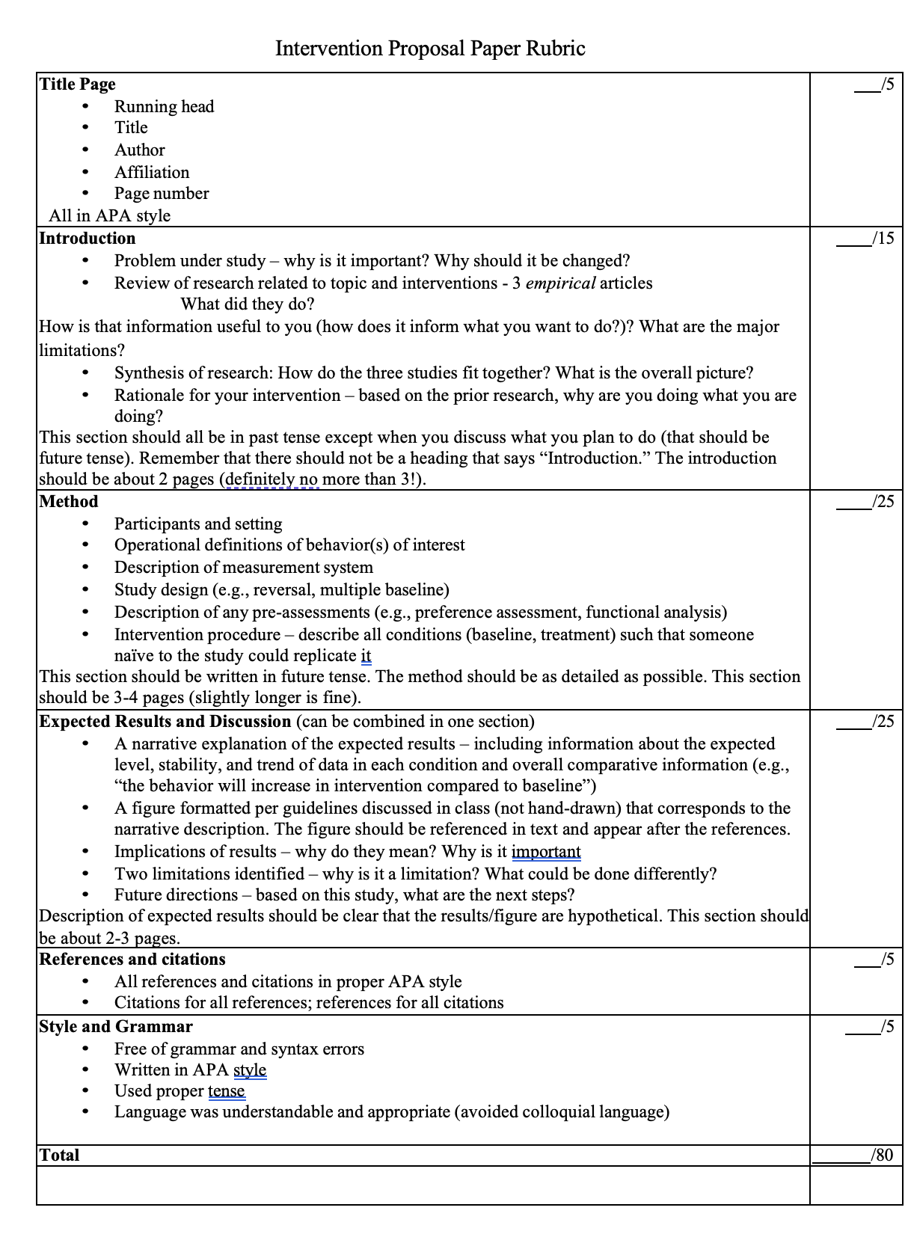
PSYC 411 Intervention Project Peer Review Form
Presenter: Peer reviewer:

Score your peers intervention proposal on each of the following categories. For any score lower than a 4, provide feedback on ways to improve or clarify.
1 = Needs work, 5+ changes or a major change recommended
2 = Okay, 3-4 changes recommended
3 = Good, 1-2 changes recommended
4 = Perfect, no changes recommended

Objective | Score
Introduction
The purpose of the intervention is clear.
Presenter has a good understanding of prior research on this topic.
Prior research presented relates to the intervention topic.
Method
The behavior to change is clearly defined.
The measurement system is appropriate.
The study design is appropriate.
The procedures for each condition are clear enough to be replicated.
Expect Results and Discussion (Peer Review 2 only)
The results are realistic and not exaggerated.
The figure matches the description of the results.
There are no alternative explanations for the expected results.
Presenter can articulate the implications (importance of expected results)
Presenter identifies and explains at least two limitations.
Presenter does not miss a major or obvious limitation.
Presenter identifies and explains at least two future directions.
Other comments and suggestions

Article Review Assignments
You will write two article reviews of behavior analytic articles. The first review will be on Hanley et al. (2007) (see syllabus for full citation). All students will review this article. The second review will be on an article of your choice from a pre-determined list. However, no two students may do the same article. We will select the articles in the first two weeks of class.

The article review should be written in APA format (typed, 12-pt Times New Roman font, double spaced, 1 inch margins). Citations and outside references are not required, but if used, should be formatted per APA guidelines. See the APA Manual or https://owl.english.purdue.edu/owl/resource/560/01/ as a guide. The finished product should be about 2-3 pages; however, this is not a strict page requirement.

Due dates and submission:
Each article review should be submitted on Blackboard by 1:00 pm on the due date.
Article Review 1: date reading is assigned
Article Review 2: varies – due on date reading is assigned
I will provide you feedback within 1 week of each submission.

It should include the following sections:
Purpose: Provide a one-paragraph summary of the purpose of the article/study.
Strengths: Identify at least two strengths of the study. At least one of the strengths must be something that you independently identified about the study (i.e., not something the authors stated in the manuscript). For each strength, you will explain why it is a strength. That is, why is it good that they did the study in that way? Dedicate about 1 page to strengths.
Limitations: Identify at least two limitations of the study. At least one of the limitations must be something that you independently identified about the study (i.e., not something the authors stated in the manuscript). For each limitation, explain why that feature of the study is problematic and what, if anything, could be done differently. Dedicate about 1 page to limitations. Note: small sample size is NOT a sufficient limitation.
Because most behavioral studies use a single-subject design, the sample sizes will be small (<10). Attempt to identify different limitations (e.g., procedures, whether or not they had control of the dependent variable).
References: provide the full reference for the article you reviewed as well as any other articles that you cited (if any).

You do NOT need to specifically include future directions, although your limitations will likely make reference to some future directions. You also do not need to provide a concluding or summarizing paragraph.

Questions to ask yourself to identify strengths and limitations:
Introduction
- Did the rationale for the study make sense? Was it logical?
- Is the topic of study important? Think big picture.
Method
- Did the authors clearly define the dependent (outcome) variable(s)? Would you know when to score the behavior based on their definition?
- Is the measurement system appropriate for the behavior(s)?
- Is the measurement system appropriate given what we know about measurement error?
- Were the procedures clearly described? Could you replicate this study based on the information provided?
- Is the study design a good design? Will it be able to tell you whether the independent variable (e.g., treatment) is the cause of behavior change?

Results and Discussion
- Is the narrative description of the results consistent with your visual analysis of the figures/tables?
- Did the researchers demonstrate experimental control of the dependent variable (i.e., did the behavior change with corresponding changes to the independent variable)?
- Can you identify alternative and plausible explanations for why behavior changed or did not change?
- Is the display of the data interpretable (e.g., clearly labeled)?
- Does the display of data potentially mask an effect? Is there a better way to display the data?
- Are the authors’ discussion points consistent with the data or do they overstate their findings and implications?
- Are the results important? Do they have meaningful implications?
- Are these results likely to be replicated in another environment or with a different population (note: see below, you must be very specific if you go this route)

Things you should not discuss as strengths or limitations:
- Sample size – most of these studies (and behavioral studies in general) will have smaller sample sizes than you may be used to). This is normal with single subject research.
- Generalizability – generalizability is often a problem; however, I want you think outside the box. If you want to comment on generalizability, you need to be very specific about why the study likely won’t generalize. It is not sufficient to say “it is unclear if this will work (in X environment or with X population).” Rather, you need a very compelling reason for why it would not work.
- Writing style – writing can make or break an article. That said, good science can often be presented in poor grammar. I want you to focus on the science aspect.

Article Review Rubric

Purpose of the study  - Very brief description of why the study was conducted – what were the authors trying to find out  - Should be no more than one paragraph | /1
Strengths  - Two strengths identified  - One strength was independently identified (not described by the authors)  - Explanation of why each is a strength: Why was what they did/said good? | /10
Limitations  - Two limitations identified  - One limitation was independently identified  - Explanation of why it is a limitation  - Description of what could have been done differently (if anything) | /10
Style and Grammar  - Free of grammar and syntax errors  - Written in APA style including references  - Language was understandable and appropriate (avoided colloquial language) | /4
Total | /25

