Reinhardt University – Fall 2023
English 101.020 – Composition
Monday, Wednesday & Friday 9:00-9:50 am
Classroom Location: Lawson Academic Center 219
Charles Jones – charles.jones@reinhardt.edu
Office Location: Center for Student Success

Welcome to English 101. This course introduces and develops analytical thinking and writing skills, with an emphasis on the organization and development of the short paper. Non-fiction prose readings, designed to stimulate critical discussion and inquiry, provide a basis for writing and support intellectual growth. Prerequisite: University placement in ENG 101; or a “P” in ENG 099 (before summer 2016) or a minimum “C” grade in ENG 100 (summer 2016 and after).

Required Texts: Foundations First 5th Edition by Laurie Kirszner & Stephen Mandell (ISBN 9781457633454) and any unabridged copy of 1984 by George Orwell—preferably a text you can annotate.

Reinhardt University Student Learning Outcomes: The four strategic domains are listed below:
Domain I: Communication
- Students will demonstrate effective expression of ideas through writing, speech and visual media.
Domain II: Critical Thinking and Inquiry
- Students will demonstrate integrative, critical thinking and inquiry-based learning using evidence, logic, reasoning and calculation.
- Students will demonstrate knowledge of various research methodologies, as well as information, technological and scientific literacy.
- Students will demonstrate independent thought and lifelong learning.
Domain III: Self, Society and Culture
- Students will demonstrate knowledge of the traditions of Western civilization and their global context.
- Students will demonstrate knowledge of the diversity of societies and cultures; the ability to view themselves and the world from cultural and historical perspectives other than their own.
Domain IV: Values and Ethics
- Students will demonstrate integrity and ethical responsibility.
- Students will demonstrate and understanding of and commitment to physical, emotional and spiritual wellness.
- Students will demonstrate stewardship and civic engagement, coupled with the ability to work with others both collaboratively and in leadership roles.
Course Learning Outcomes: English 101 is a general education core curriculum course. This section addresses all four Domains of the RU student learning outcomes. The class improves communication and critical thinking with readings from various historical periods, societies, and cultures. Students should respond with respect but not gullibility to these texts. Many of the ideas in the readings as well as the skills in writing concern values and ethics. Students learn to use paraphrase and direct quotations in ways that are grammatically correct, rhetorically effective, ethically sound.

Grading: Do consistent work across the entire semester (with prompt attendance & not disturbing class) and you will do fine in the course. The grading scale breaks down in the following manner: A: 90-100; B: 80-89;
C: 70-79; D: 60-69; F: 59-below. Not attending class on a regular basis along with class disturbance will impact the final grade—possibly as much as a full-letter grader. This includes tardiness. Keep track of grades by keeping track of scores.
Major Essay 30% Minor Essays 30% Presentations 30% Assignments 10%
A (90-100) The A essay is an example of excellence. It meets all and exceeds most of the criteria for a B essay. The A essay approaches the argument as a complex problem with multiple possible solutions depending on one’s point of view but argues its thesis with thorough and thoughtful planning and research, keen insights, detailed analysis, and impeccable logic. In other words, this essay goes beyond the obvious, diving into subtext while using sophisticated syntax and diction and even an occasional rhetorical flourish. The use of sources is clever, respectful, and instructive, and the writer may reach novel or creative solutions not suggested by the sources. The paper cannot be faulted for its use of MLA style.

B (80-89) The B essay shows distinction. It meets all and exceeds most of the criteria for a C essay but at times will state the obvious without diving deeply into subtext. The ideas are expressed freshly and vividly, and the essay arouses the reader’s interest to a greater extent that the typical C essay. The essay may incorporate more than the required number of scholarly sources. The essay cites primary and secondary sources appropriately in MLA style with few or no errors in formatting.

C (70-79) The C essay meets the basic criteria for a college essay. It has a central idea related directly to the assigned topic and presented with sufficient clarity that the reader is aware of the writer’s purpose, but that central purpose and idea are too obvious. The organization is clear enough for the reader to perceive the writer’s plan but that plan never really delves into subtext. The paragraphs coherently present some evidence or details to substantiate the points. The writer uses ordinary, everyday words accurately and idiomatically and generally avoids both the monotony created by series of choppy, simple sentences and the incoherence caused by long, tangled sentences. Although the essay may contain a few serious grammatical errors and several mechanical errors, they are not of sufficient severity or frequency to obscure the sense of what the writer is saying. The essay cites primary and secondary sources appropriately in MLA style, although there may be some errors in the formatting of entries in the works cited and in-text references.

D (60-69) The D essay fails to demonstrate competence. It has any one of the following problems to an extraordinary degree or it has several to a limited degree: it lacks a central idea; it lacks a clear organizational plan; it does not develop its points or develops them in a repetitious, incoherent, or illogical way; it does not relate directly to the assigned topic; it contains several serious grammatical errors; it contains numerous mechanical errors; ordinary, everyday words are used inaccurately and unidiomatically; it contains a limited vocabulary so that the words chosen frequently do not serve the writer’s purpose; syntax is frequently rudimentary or tangled; or the essay is so brief that the instructor cannot make an accurate judgment of the writer’s ability. The essay does not cite an adequate number of sources, or it may cite sources without any attempt to follow MLA style.

F (<60) The F essay is a less-than-half-hearted attempt to complete the assignment. The essay may not make sense. It may contradict itself. It may not be on the topic. It may difficult to read because of its grammatical and mechanical errors. It may sound childish or abusive. The essay may fail to cite secondary sources, or it may plagiarize them. Indeed, plagiarism alone may justify a grade of F. The essay may lack development or cite examples that do not illustrate the claim under question.

Policy Statement: While the syllabus is subject to change, please take the time to read the entire syllabus and ask questions if a policy seems unclear. That said, should you ask about any class policy, I will generally refer to the syllabus in order to guide and decide course decisions. While certainly not a perfect document, this syllabus will nonetheless act as a founding document for the course; we will reference it frequently.

Creative Writing: There could be creative writing assignments—original poems, micro-fiction, satires. Such assignments are designed to help you better appreciate a particular genre. As such, they will be graded on originality and insight, along with punctuality and professionalism. That said, you don’t have to fancy yourself a “creative writer” in order to excel on these assignments. Please, have fun with such assignments.

Applicable Revision: Certain assignments might be revisable—as directed by the professor. In general, assume an assignment—especially an essay—is not revisable. Then, you will be pleasantly surprised when such an opportunity presents itself. As is the case, revisions will only improve by about five to eight points—or a portion of a letter grade. So, it’s vitally important that you vest time with the original assignment. Improved scores are not guaranteed on a revision—although scores will never be lowered. In order to submit a revision, you must follow ALL of these guidelines: 1) You must include all the edits marked on the original assignment, even if you disagree with them; 2) You must resubmit the original, graded assignment for the revision to be considered. I will not accept a revision without the original, graded assignment. Don't misplace the original assignment; 3) If the new revision is an essay, then it must be typed--no handwritten essays.

Grammar: Before entering this class, you should have already mastered the basics of correct grammar and punctuation—especially fragments and run-on sentences. Problems with grammar and punctuation will result in significant point deductions on papers and prevent you from passing the class. If you continue to struggle with grammar and punctuation, you will be referred to the Center for Student Success for mandatory tutoring.

Attendance & Tardiness: Because of the nature of this class, attendance at all meetings is essential. If you must miss a class, be sure to get reliable notes from someone. If you miss more than 4 classes, your course grade will be dropped one letter grade. If you miss more than 6 classes, it is highly probable that you will receive an F in the course. It is your responsibility to notify me in advance when you must be away for an excused activity. In the event of illness or other valid reason for absence, please bring me a note from your doctor or other form of documentation. Come to class. Be on time. Also, three “tardies” equal an absence. If you arrive to class five or more minutes late, then attendance for that day will count as an absence. A tardy should be corrected on the day it occurs at the end of that particular class. Tardiness will not be changed after the date in question. Please be proactive should you arrive late, otherwise you will be marked absent. Please see me at the end of class (that same day) in order to correct the absence.

Use of Electronic Devices in the Classroom: Electronics are an important aspect of any class. That said, the use of electronic devices, such as laptops, cell phones, text messaging devices, and personal digital assistants (PDAs) for any reason other than coursework for the class in which the student is in attendance or in a manner that causes distraction or disturbance to other students or myself is prohibited. I reserve the right to permanently ban electronic devices from the classroom if I observe that they are causing a distraction. Furthermore, the use of any electronic devices during a test is prohibited. The use of any electronic devices during any student presentation will not be permitted. Each student will be expected to give full attention to each presentation. Should we have someone visiting the class (i.e. potential student, guest speaker, another professor or administrator) electronic devices are not allowed. Should the improper use of electronic devices continue—ad nauseum—then the final grade in the semester will be impacted by as much as a full-letter grade or more. Please control the use of electronic devices.
Make-up Policy: Make-up work is the exception and not the rule and is given at the discretion of the professor. Students who have conflicts because of university-sponsored events are required to notify the professor at least one (1) week ahead of the announced test/assignment date. Failure to do so will forfeit the student’s opportunity for an alternate test/assignment date. Only in extreme circumstances will make-up tests be given for other reasons. Extreme circumstances are illness, death in the family, accident, etc. To be eligible for a makeup/extension due to extreme circumstance, the student must observe the following requirements: 1) contact the professor within 24 hours of the missed deadline; 2) provide a written excuse from an appropriate health, academic, or other professional (medical doctor, therapist, college counselor, police officer, etc.) within 24 hours. Otherwise, late work will be penalized accordingly. Generally, late work drops by a letter grade or even more. It’s always to your advantage to complete make-up work, but that said, you need a written excuse to justify the late work in order to avoid point deductions. Don’t count on me asking for a written excuse, the assumption being you will provide a written excuse if available. Even with point deductions, make-up is always in your best interest as a student.
Food: While drinks and snacks are permitted, please refrain from eating meals in the classroom. It is your responsibility to eat before or after class. That said, food is not allowed in classes with computer hardware, although bottled water is acceptable.
Contacting the Professor: If you have a question about the course, its content, or its execution, the contact information listed at the beginning of this syllabus constitutes the best method of contacting me. Email through your school email account and not your Canvas account as the school email is more efficient. That said, check both accounts daily—email and Canvas—as I could communicate with the class via one method or even both.
Final Exams & Travel Plans: Final exams will not be administered early or late. Be present and punctual for the final exam (date and time noted on this syllabus or specified by University). All travel must schedule itself around this syllabus, so plan your travel according to the dates published by the university along with those specific dates and requirements noted on this syllabus. This includes but is not limited to all breaks and holidays: Labor Day, Thanksgiving, Winter Break, Spring Break, Fall Break, Summer Break, etc. all.
Typed & Printed Work: Generally, all work should be typed and printing concerns addressed prior to the due date as this will impact your grade on any given assignment. Concerns include log-in issues, printer access, etc. Submit typed (Times New Romans/12 pt.), hardcopy work if in doubt. Work is due at start of assigned class.

Due Dates for Assignments: All work is due at the start of class on the day assigned—else that work is late. Address all printing and supply issues prior to the due date and the start of the relevant class.

Uncollected/Unclaimed Work: If you are not in class when graded assignments are returned, then it is your responsibility to schedule the return of the graded work. Generally speaking, uncollected work is filed but always available with notice. That said, work will be kept for two weeks after final exam—then discarded.

Academic Integrity: All students are expected to adhere to the highest standards of academic integrity, and to abide by the Reinhardt Honor Code. Also, all students are expected to be familiar with the Reinhardt policy on academic dishonesty stated in the University Catalog and in the Student Handbook. Plagiarism (using the ideas and phrases of others without crediting them, therefore claiming those ideas and phrases as your own) will not be tolerated in this course or on this campus. To avoid such academic dishonesty, you must use a citation (footnote or in text) for all ideas drawn from your reading and research, including research in encyclopedias and online, even when you have restated those ideas in your own words. Representing work generated by artificial intelligence as one’s own work is considered to be academically dishonest. Having artificial intelligence write your paper (or even answer formal questions) constitutes plagiarism. If the source of the work is unclear, I may require you to meet with me to explain the ideas and your writing process.

There are severe consequences for cheating or plagiarizing on assignments: a) There are several forms of plagiarism. If you cheat on a quiz or test, you fail the test with a 0 grade. If you turn in someone else’s work as your own paper, you fail the paper with a 0 grade; b) The Office of the Provost will be notified of actions taken against any student who violates the academic integrity policy, which may result in further consequences, including designation of “academic warning” on your official transcript, academic suspension, or expulsion for academic reasons.

Academic Support: The Americans with Disabilities Act (ADA) is a federal anti-discrimination statute that provides comprehensive civil rights protection for persons with disabilities. This legislation requires that all students with disabilities be guaranteed a learning environment that provides for reasonable accommodation of their disabilities. Reinhardt University is committed to providing reasonable accommodations for all persons with disabilities. Therefore, if you are seeking classroom accommodations under the Americans with Disabilities Act, you are required to register with the Academic Support Office (ASO). ASO is located in the basement of Lawson Building. The Director of ASO is Mr. Tunji Adesesan. To receive academic accommodations for this class, please obtain the proper ASO letters. Contact ASO at 770-720-5567 or contact Mr. Tunji, ASO Director, at AAA@reinhardt.edu.

Center for Student Success: The Center for Student Success, located in room 035 of Lawson, offers free peer and faculty tutoring for all subjects. To make an appointment, go to Reinhardt's homepage and click on Academics>Undergraduate>Resources>Center for Student Success. You may also access the website at www.reinhardt.edu/css . This next page enables you to see tutors and times available for each subject area. At the bottom of the left column, click on Student Appointment Form. Fill in all required fields, signaled by a red dot, and submit your request. Dr. Emanuel will contact you within the same day to confirm your appointment.

_________________________________________________________
You are acknowledging your understanding and agreement with class policies
and with the syllabus in general by remaining enrolled in this class.
This acknowledgment includes the fact you have taken the time to read the
entire syllabus and that you fully understand the course requirements, including those
related to final exams, attendance, and tardiness.
You also express a willingness to check (daily) your
school email and Canvas email for updates and announcements specifically related
to this course of study. See class calendar below. Calendar subject to change.
Also, if needed, we could change course parameters due to Covid or similar.
I also wish to thank the following institution and professors for allowing me to use parts of
their syllabi in the design of this course—specifically Brandeis, Dr. Morlier and Dr. Glowka.
Wise insights are greatly valued and appreciated.
_________________________________________________________

Class Calendar
Follow this schedule (subject to change), completing all assignments prior to class—unless directed otherwise. Come to class with knowledge of the material, along with textbook, device for viewing online content, pen/pencil, paper, folder to keep semester work. FF = Foundations First. 1984 = novel by George Orwell.
On August 18, go to “Hand Tools Hall” at the Bennett Museum—not the classroom. See writing assignment below.
Week 1
Aug 14
- Roll Call & Welcome
- Syllabus & Textbooks
- Run-On Sentences (fuses, commas & semicolons)
“Frame 352” Patterson/Gimlin (1967:3min) HD Enhancements (30sec) Commentary (5min)
See Practice 19-2, FF p. 265
“Dr. Seuss” Bio (grudgingly use Wiki but never cite it)
See Practice 19-6, FF p. 269

Aug 16
- Fixing Run-Ons with Dependent Words—“Harry Potter” FF, p. 270-271 & “Call Centers” FF, p. 272

- Preparing for First Essay --- “So, What’s in Your Toolbox?” DUE Aug 25
For thousands of years, people have relied on hand tools; think a carpenter’s compass, a chimneysweep and make-up artist’s brushes, a writer’s pen, a priest’s crucifix. In fact, “hand tools” define a profession. That said, “hand tools” also have the unique ability to explain someone: hobbies, interests, amusements, for example. With that in mind, what “hand tools” do you use? How do they define you? Explain these “hand tools” in a well-written, introductory essay. Specifics: typed, two pages, Times New Roman 12 pt. font, MLA headers & margins. Due at the start of class on the due date—as are all formal papers.

- Writing a Paragraph
Freewriting Clustering, FF p. 43
Brainstorming, FF p. 41 Journal Writing/Pre-Writing, p. 45
Topic Sentence, FF p. 47 (exercise)

- Paragraph Samples
Paragraph Structure, FF p. 36 [Study these sample paragraphs, especially “Waiting.”]
Paragraph: “Waiting,” FF p. 55
On August 18, go to “Hand Tools Hall” at the Bennett Museum—not the classroom.
Aug 18
- Roll Call

- Hall of Hand Tools @ Bennett Museum

- Paragraph Structures Considered
General Paragraph Structure: “Silly Rules,” FF p. 58
Time-Order Paragraphs: “Ralph Ellison,” FF p. 70
Spatial-Order Paragraphs: “My Great Grandmother’s House,” FF p. 72
Logical-Order Paragraphs: “Priorities,” FF p. 74

- Paragraphs (Not Unified v. Unified --- Developed v. Undeveloped)
Paragraph Unity: “Applying for a Bank Loan,” FF p. 59
Paragraph Development: “Why We Need to Stop Buying Bottled Water,” FF p. 65
See Practice 3-7, FF p. 66
See Practice 3-8, FF p. 67
Week 2
Aug 21
- Roll Call

- Paragraphs & Topic Sentences
See Practice 3-1, FF p. 60
See Practice 3-2, FF p. 60
See Practice 3-3, FF p. 61
See Practice 3-4, FF p. 62

- Paragraphs & Summary Statements
Sample Paragraph: “Colorful Rooms,” FF p. 69
See Practice 3-10, FF p. 69
- Writing a Paragraph
In-Class Writing Exercise (this class or next class…depending on time)

Aug 23
- Roll Call

- Fixing Fragments with Rango (parked across street from Dash)
See Practice 20-2, FF p. 279

- Fixing Dependent Clause Fragments
See 20f, FF p. 287-288

- Essay Structure
Overview, FF p. 174
Sample: “My Grandfather’s Lessons,” FF p. 175
First Draft Sample: “Facebook,” FF p. 181
Final Draft Sample: “Facebook,” FF p. 185
Identifying the Effective Thesis, FF p. 179

- Applying Essay Structure
Cluster “Hand Tools” in Paragraph Order

Aug 25
- Roll Call

- Essay DUE: “So, What’s in Your Toolbox?”

- Even Little Essays Can Aspire to Greatness
Read “Are Smartphones Turning Us into Bad Samaritans? Busy with our Tablets and Smartphones in Public Places, We May be Losing Our Sense of Duty to Others” by Christine Rosen, FF p. 25
Title: Antonym & Story of Good Samaritan (Luke 10: 25-37)
Para 1-3: Pathos, the Triptych & The Garden of Earthly Delight
Para 4: Thesis & Weegee Crime Photo 1 Crime Photo 2
Para 5 & 6: Diptych
Para 7 & 8: Ethos & the “Scripture” of Scientific Studies
Para 9: Geomantic Mandala—How does this paragraph form a figurative mandala?
Para 1-9: “Stained Glass” metaphor…series of smartphone pics…no better than Weegee.
Question: Is this a religious essay? Why can we so easily use religious terminology to explain it?
Week 3
Aug 28
- Roll Call

- Working with Sentences (Shifts in Tense)
See Practice 22-1, FF p. 309

- New Yorker Cover (see below) & 1984 Apple TV Spot

- “How to Recognize a Dystopia” by TED-Ed & “What ‘Orwellian’ Really Means” by TED-Ed

- Intro to George Orwell’s 1984 & Dystopic Literature
Research Question: Using 1984 as a guidebook, do you live in a dystopia? This question stands at the center of your research this semester. This touchstone essay will be well-researched and well-written; it will count for 30% of your final grade. See “1984 Reading Guide” in Canvas.

Specifics: typed; 5-6 pages; ten authored sources from reputable writers—no blogs; Wikipedia or the like;
Times New Roman 12-pt. font; MLA headers & margins; MLA Works Cited; use signal phrases & parenthetical citations; proofread for grammar, syntax, and spelling. DUE October 30

Aug 30
- Roll Call

- Working with Sentences (Shifts in Person)
See Practice 22-2, FF p. 311

- 1984 (Model Read: Part I—Chapters 1-3)

Sept 1
- Roll Call

- Working with Sentences (Shifts in Voice)
See Practice 22-3, FF p. 312

- 1984 (Model Read: Part I—Chapters 1-3)

1984 Structural Breakdown

Part I – Chapters 1-8

Part II – Chapters 1-10

Part III – Chapters 1-6

Orwell’s Rhetorical Toolkit
Note where Orwell uses aposiopesis, ecphonesis, pysma, parataxis, and praeterition. How might these rhetorical devices help to convey a dystopic worldview?
Week 4
Sept 4
No Class – Labor Day

Sept 6
- Roll Call

- Work with Sentences (Phrases between Subjects & Verbs)
See Practice 21-8, FF p. 302

- 1984 (Model Read: Part I—Chapters 4-6)

Sept 8
- Roll Call

- 1984 (Model Read: Part I—Chapters 4-6)

- 1984 Travelogue Essay DUE Sept 18
Pretend you’re a travel writer; write a travelogue for a would-be traveler to London in Airstrip 1 in Oceania. As you write, capture the spirit and tone of the town. Note things to do, sights to see, restaurants to visit. Quote from the novel at least ten times, all the while using signal phrases and parenthetical citations. Since Oceania is a place you probably don’t want to visit, then change your point-of-view; write from the standpoint of a party member. That said, you might even find yourself using sarcasm or even satire to describe London. But, be careful with that approach because the Thought Police might get you.

See “El Hoyo” by Mario Suárez (FF, p. 523) for some tips on writing about place. Might you write about Oceania in the same way Suárez writes about “El Hoyo,” at least in part?

Specifics: two pages, typed, Times New Roman 12 pt. font, MLA headers & margins, ten quotes, signal phrases, parenthetical citations, Works Cited. Due at the start of class on the due date—as are all formal papers.
------------------------------------------------------------------------------------------------------------------------------
Class Notes – use this space for notes and ideas

Week 5
Sept 11
- Roll Call

- Argumentation & the Art of Procatalepsis Part I
Read “What is Argument?” FF p. 162-164
Argument Map, FF p. 163
Read Paragraph Argument: “Taxing Soda,” FF p. 164
Read “Don’t Hang Up, That’s My Mom Calling” by Bobbi Buchanan, FF p. 500
Analyze Argument
Assess Use of Three Appeals: Ethos, Pathos, Logos
Will Call Center Jobs Disappear Video (9min)

- Work with Sentences—Reviewing Compound Sentences (FANBOYS--for, and, nor, but, or, yet, so)
See Practice 15-2, FF p. 208 [Note commas before coordinating conjunctions.]

Sept 13
- Roll Call

- Work with Sentences (Simple Sentences)
See Editing Practice, FF p. 204

- 1984 (Model Read: Part I—Chapters 7-8)

Sept 15
- Roll Call

- 1984 (Model Read: Part I—Chapters 7-8)

If you miss any classes, have Part I finished by September 20.
------------------------------------------------------------------------------------------------------------------------------
Class Notes – use this space for notes and ideas

Week 6
Sept 18
- Roll Call

- DUE 1984 Travelogue Essay

- Exemplification & Skateboards
Read “What is Exemplification?” FF p. 81-83
Exemplification Map, FF p. 82
Read Paragraph Exemplification: “The Trouble with Lotteries,” FF p. 82
Read “Do What You Love” by Tony Hawk, FF p. 512
Analyze Essay
Assess Use of Three Appeals: Ethos, Pathos, Logos
Tony Hawk Video (8min)

- DUE September 22. What do You Love? Give a 2-minute exemplification presentation that answers this question. You may use notes but don’t read them—deliver them, so the person sitting in the back row can hear. Practice your presentation, so it comes in between 1:50 & 2:10. For sake of time, we’ll have to stop you once you cross the 2:10 barrier…so, practice, practice.

- Practice Presentation: Use “Three Silly Rules” (p. 58) to practice delivering oral content. If fact, your presentation (the written portion) would look very similar to “Three Silly Rules.” Try to deliver it in two minutes. If you come in @ 1:30, what might you do to expand it? Answer: elaborate on a point or two; add a fourth rule; slow delivery pace so as to better engage your audience; use silent pauses. If you come in @ 2:30, what might you do to reduce it? Answer: cut a rule; provide a bit less elaboration; increase delivery pace but not to the extreme; avoid long pauses.

Sept 20
- Roll Call

- Work with Sentences—Forming Compound Sentences (Transitional Words & Phrases)
See 15c, FF p. 213-214

- 1984 (Model Read & Independent Read: We’ll start Part II in class—you’ll finish Part II by September 27)

Sept 22
- Roll Call

- Give Exemplification Presentations

Week 7
Sept 25
- Roll Call

- Narration & Pretzels
Read “What is Narration?” FF p. 91-92
Narrative Map, FF p. 92
Read Paragraph Narration: “Overnight Success,” FF p. 92
Read “The Little Pretzel Lady” by Sara Price, FF p. 522
Analyze Essay
Assess Use of Three Appeals: Ethos, Pathos, Logos

- DUE September 29. What Narrative Defines You? Give a 2-minute narrative presentation that answers this question. You may use notes but don’t read them—deliver them, so the person sitting in the back row can hear. Practice your presentation, so it comes in between 1:50 & 2:10. For sake of time, we’ll have to stop you once you cross the 2:10 barrier…so, practice, practice.

- Work with Sentences—Complex Sentences & Subordinating Conjunctions
See 16a, FF p. 222
See Practice 16-1, FF p. 223

Sept 27
- Roll Call

- Part II (Key Moments)

- 1984 (Model Read & Independent Read)
Start Part III in class—you finish up to Part III Chapter 5 by October 3.
Don’t read Part III Chapter 6.
We will read Part III Chapter 6 together in class on October 3.
If you miss any classes, 1984 should be read in its entirety by October 10.

Sept 29
- Roll Call

- Give Narrative Presentations
------------------------------------------------------------------------------------------------------------------------------
Class Notes – use this space for notes and ideas

Week 8
Oct 2
- Roll Call

- Work with Sentences—Complex Sentences (review)
See 16a, FF p. 222
See Practice 16-1, FF p. 223

- Part III: Chapters 1-5 (Key Moments)

- 1984 (Model Read Part III: Chapter 6—We’ll read final chapter together in class.)

Oct 4
No Class – Fall Break

Oct 6
No Class – Fall Break
------------------------------------------------------------------------------------------------------------------------------
Class Notes – use this space for notes and ideas

Week 9
Oct 9
- Roll Call

- Argumentation & the Art of Procatalepsis Part II
Read “What is Argument?” FF p. 162-164
Argument Map, FF p. 163
Read Paragraph Argument: “Taxing Soda,” FF p. 164
Read “It’s Possible to Graduate Debt Free” by Rebekah Bell, FF p. 498
Analyze Argument
Assess Use of Three Appeals: Ethos, Pathos, Logos
Debt Free Video (8min)

- DUE October 13. Pick an argumentative topic from below and develop a 2-minute argument. You may use notes but don’t read them—deliver them, so the person sitting in the back row can hear. Practice your presentation, so it comes in between 1:50 & 2:10. For sake of time, we’ll stop you once you cross the 2:10 barrier…so, practice, practice.

Topics: 1) Boots or Birkenstocks? Explain; 2) Country or City? Explain; 3) F2F or Online? Explain; 4) Truck of Car? Explain; 5) Star Wars or Star Trek? Explain; 6) Rap or Rock? Explain; 7) Tom Brady or Tom Cruise? Explain; 8) Lizzo or Puddles Pity Party? Explain; 9) NBA or WNBA? Explain; 10) NFL or MLB? Explain;
11) Patterson/Gimlin: Real or Hoax? Explain; 12) Loch Ness? Real or Hoax?

Oct 11
- Roll Call

- Library Research

Oct 13
- Roll Call

- Give Argumentative Presentation
------------------------------------------------------------------------------------------------------------------------------
Class Notes – use this space for notes and ideas

Week 10
Oct 16
- Roll Call

- Process & Tattoos
Read “What is Process?” FF p. 111-113
Process Map, FF p. 112
Read Paragraph Explanation: “How a Fire Extinguisher Works,” FF p. 112
Read Paragraph Instruction: “Man v. Machine,” FF p. 113
Read “Getting a Tattoo: The Process” by Karen Hudson, FF p. 514
Analyze Essay
Assess Use of Three Appeals: Ethos, Pathos, Logos
Tattoo History Video (5min)

- DUE October 20. Explain or instruct some interesting process. Give a 2-minute instruction or explanation. You may use notes but don’t read them—deliver them, so the person sitting in the back row can hear. Whatever process you choose, it is first come, first serve. Practice your presentation, so it comes in between 1:50 & 2:10. For sake of time, we’ll stop you once you cross the 2:10 barrier…so, practice, practice.

When I did this assignment, I showed the process of how to properly utilize a banana: 1) how to peel it—as it’s never done correctly; 2) how to make a banana split; 3) how to polish dress shoes with the peel; 3) how to compost the peel…all in two minutes. It was TikTok before there was Tiktok. If you would like to do a 2-minite “process” TikTok, you can; it must be viewable on classroom’s projector. Trouble-shoot before the due date.

Oct 18
- Roll Call

- Library Research

Oct 20
- Roll Call

- Give Process Presentation
------------------------------------------------------------------------------------------------------------------------------
Class Notes – use this space for notes and ideas

Week 11
Oct 23
- Roll Call

- Description & Foodways
Read “What is Description?” FF p. 101-103
Descriptive Map, FF p. 102
Read Paragraph Description: “The Lincoln Memorial,” FF p. 122
Read “Chili Peppers” by Jeremy MacClancy, FF p. 520 & “Tortillas” by José A. Burciaga p. 501
Analyze Essays
Assess Use of Three Appeals: Ethos, Pathos, Logos
Science of Spice Video (4min)

- DUE October 25. Describe a food that has impacted your life. Give a 2-minute description. You may use notes but don’t read them—deliver them, so the person sitting in the back row can hear. Ideas: carnivore lifestyle; communion/Lord’s Supper, Thanksgiving turkey, Christmas deserts, a church fish fry; a pizza joint you frequent, hot dogs at a ballpark, warm biscuits at Grand-ma’s; family BBQ secrets; taco night. Practice your presentation, so it comes in between 1:50 & 2:10. For sake of time, we’ll stop you once you cross the 2:10 barrier…so, practice, practice. [Note due date for this speech is a little different…delivered on a Wednesday.]

When I did the assignment (twice): 1) Saltines & Welch’s Grape Juice—As I lived in a pastorium next to a church, I would frequently “break-in” to eat the Lord’s Supper. Once, I ate a bit too much, and when Sunday rolled around, all the saltines and juice had been consumed by yours truly. The Head Deacon said, “I’m glad we’re Baptist or that boy would be drunker than a skunk; 2) Mullet & Flounder—As I lived along the Gulf of Mexico, Jubilees would occur occasionally. My friends and I would comb the beach picking up mullet and flounder and frying them in Crisco. It was “fish & friendship” along the coast.

Oct 25
- Roll Call

- Give Descriptive Presentation

Oct 27
- Roll Call

- 1984 & Impact on Modern Culture
Read “What is Comparison and Contrast?” p. 131-134
Read “The Online Alternative” by Marc Williams, FF p. 526

- Visual Arguments: Dystopic Cinema
Screen Matrix
------------------------------------------------------------------------------------------------------------------------------
Class Notes – use this space for notes and ideas

Week 12
Oct 30
- Roll Call

- Visual Arguments: Dystopic Cinema
Screen Matrix

Nov 1
- Roll Call

- Visual Arguments: Dystopic Cinema
Screen Matrix

Nov 3
On Nov 10, go to Bennett Museum—not the classroom.
- Roll Call

- Visual Arguments: Dystopic Cinema
Screen Matrix

------------------------------------------------------------------------------------------------------------------------------
Class Notes – use this space for notes and ideas

Week 13
Nov 6
- Roll Call

- Visual Arguments: Books & their Importance—The New Yorker on Books and the Bookstore
a. New Yorker Cover Dec. 25, 2000
(subway) https://www.newyorker.com/magazine/2000/12/25
On Nov 10, go to Bennett Museum—not the classroom.
b. New Yorker Cover Oct. 18, 2010
(books with eyes) https://www.newyorker.com/magazine/2010/10/18
c. New Yorker Cover Nov. 8, 2004
(passing interests) https://www.newyorker.com/magazine/2004/11/08
d. New Yorker Cover Dec. 3, 1990
(bed of books) https://www.newyorker.com/magazine/1990/12/03
e. New Yorker Cover Dec. 26, 2005
(airport books) https://www.newyorker.com/magazine/2005/12/26
f. New Yorker Cover Oct. 5, 1998
(book furniture) https://www.newyorker.com/magazine/1998/10/05
h. Now Landing—Books Away
(cartoon) https://www.allposters.com/-sp/In-preparation-for-landing-please-turn-off-your-books-New-Yorker-Cartoon-Posters_i9186532_.htm
i. New Yorker Cover Feb. 25, 2008
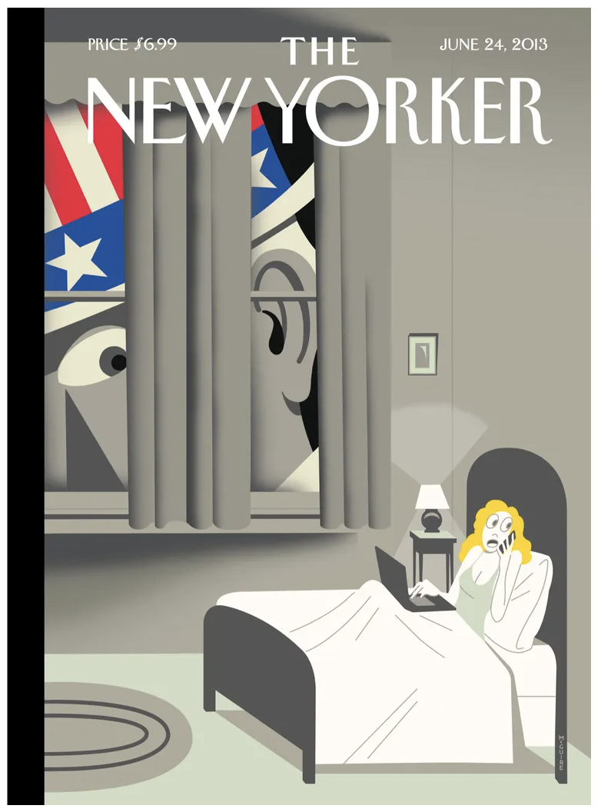
(book lifecycle) https://www.newyorker.com/magazine/2008/02/25
j. New Yorker Cover June 9, 2008
(Amazon v. local books) https://www.newyorker.com/magazine/2008/06/09
k. New Yorker Cover Oct. 19, 2015
(It’s you, Daddy!) https://www.newyorker.com/magazine/2015/10/19
l. New Yorker Cover Mar. 15, 1982
(book buildings) https://www.newyorker.com/magazine/1982/03/15
m. New Yorker Cover June. 11, 2007
(sightseeing book) https://www.newyorker.com/magazine/2007/06/11
n. New Yorker Cover Dec. 5, 2011
(generation gap) https://www.newyorker.com/magazine/2011/12/05

Nov 8
- Roll Call

- Visual Arguments: Books & their Importance (cont.)
Uncle Sam is Listening by Richard McGuire

Nov 10
On Nov 10, go to Bennett Museum—not the classroom.
- Roll Call
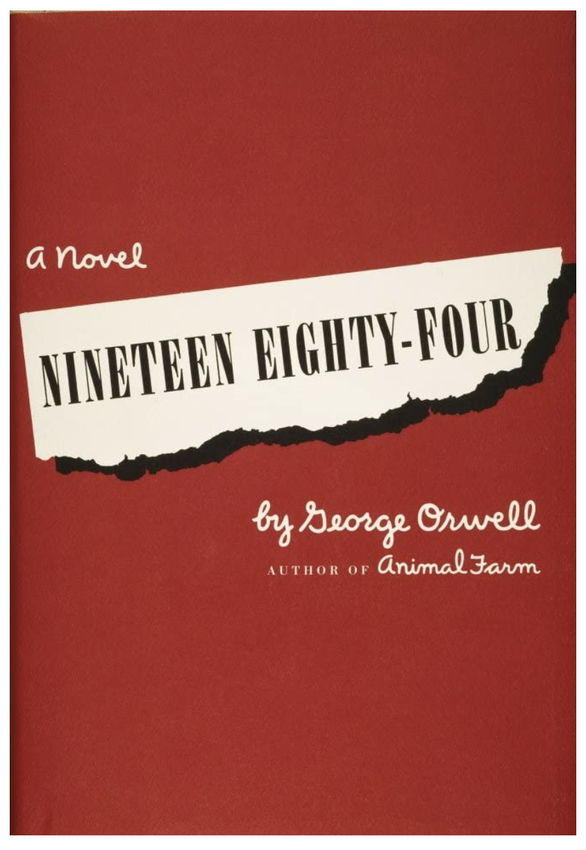
- The 3-D Essay
-----------------------------------------------------------------
Class Notes – use this space for notes and ideas
Book Cover from 1949
Week 14
Nov 13
- Roll Call

- Visual Argumentation: Dystopia v. dystopia (screen Jasper Mall)

Nov 15
- Roll Call

- Visual Argumentation: Dystopia v. dystopia (screen Jasper Mall)

Nov 17
- Roll Call

- Visual Argumentation: Dystopia v. dystopia (screen Jasper Mall)
------------------------------------------------------------------------------------------------------------------------------
Class Notes – use this space for notes and ideas

Weeks 15 & 16
Nov 20
- Roll Call

- Thanksgiving New Yorker covers

- What Have We Learned? (Reviewing Writing Forms & Strategies)
Argumentation, FF p. 61 Other Forms
Definition, FF p. 151 Classification, FF p. 142
Exemplification, FF p. 80 Cause and Effect, FF p. 120
Narration, FF p. 90
Description, FF p. 100
Process, FF p. 110
Compare/Contrast, FF p. 130
[This is our last regular class; finals begin after Thanksgiving.]

Nov 22
No Class – Thanksgiving

Nov 24
No Class – Thanksgiving

Final Exam – Wednesday, November 29 @ 11:15 a.m. – 2:15 p.m.

